

Development of the Microsimulation Model in Cancer of the Bladder (MiMiC-Bladder)

Technical Document

Contents

Model Structure 4

Model Population 7

Baseline Phenotypic Characteristics 7

Missing Data for Phenotypic Characteristics 8

Risk factors included in the model 9

Other risk factors not included in the model 10

Modelling Changes in Phenotypic Characteristics by Age 10

Smoking 10

EQ-5D 11

Reconstructing population of England for model calibration and analysis 11

Model population size 13

Natural History of Bladder Cancer 14

Probability of cancer onset 14

Probability of disease progression 15

Calibration parameters 16

Calibration targets 16

Survival 18

Mortality from other causes 22

Screening 25

Screening Eligibility 25

Screening Uptake 26

Sensitivity and False Positives 28

Surveillance 28

Utilities 29

**DON’T LOOK FROM HERE** 30

Resource use and costs 30

Diagnostic costs 30

BC Treatment Costs 31

Screening and Further Investigation Costs 33

Appendix A: Parameter Table 35

# Model Structure

Microsimulation Model in Cancer of the Bladder (MiMiC-Bladder) is an individual patient simulation model built in the R programming language, which has been designed to enable comparison of the effectiveness, cost-effectiveness and resource use of screening strategies for bladder cancer (BC) among different population groups. The model simulates the life course of patients, and can represent different populations, including the population of England and the population of Yorkshire. Each person in the model has a set of individual characteristics which determines their cancer risk and response to screening and surveillance. The model has a lifetime horizon and takes ay NHS perspective. The model was built to inform the design of the YORKSURE trial that aims to assess the feasibility of urinary dipstick self-testing as an early detection method for BC in three populations.

Underpinning the model is a natural history disease (NHD) module. Within the NHD component, each patient may develop low-risk non-muscle-invasive bladder cancer (NMIBC) and BC that has a potential to progress to muscle-invasive bladder cancer (MIBC) with a probability of cancer onset dependent on age, sex, smoking status (past and current smoker), and occupational exposure. While there is some evidence that higher incidence of BC among males is likely to be attributable to the risk factors1, this correlation is not well-explored and so BC onset will be still considered to be dependent on sex. There are different classification systems for BC diagnosis. The model will use classification of low-risk and high-risk BC; for high-risk BC, Stages 1 to 4 (with the Stage 4 commonly classified as MIBC and stages 1-3 as NMIBC), similar to the Office for National Statistics UK and CRUK.

The model assumes that only cancer onset and not the disease progression is dependent on the risk factors. In the model, for people who had an onset of low-risk BC, the probability of being diagnosed symptomatically will be time-independent, assuming mainly the casual or chance findings. For people who had an onset of high-risk cancers stage 1 to stage 4, a disease-progression state will be assigned as a function of the time since cancer onset. The probability to become an incident case (i.e. diagnosed) is also a function from the time of BC onset (see the Natural History Disease section). It is assumed that patients who become symptomatically diagnosed will follow the treatment pathway which includes treatment costs, utility reductions and reduced survival compared to the general population.

Onset high risk tumours

Age onset

Sex onset

Smoking

Occupation

Diagnosis

Time t

Onset low-risk

Diagnosis

Age, t

Stage 1

Age, sex, t

Stage 2

BC Death

Stage 3

Stage 4

#### Figure 1: Structure of the natural history disease in the bladder cancer model

The model has two absorbing states. Whilst all individuals have a probability of dying from other causes, only those high-risk cancers who have Stage 1-4 BC can die from BC. It is not possible that individuals can die from undiagnosed BC (based on the consultations with the clinical experts), assuming that all BC will be diagnosed before death or post-mortem (reflecting the national incidence and mortality data).

The screening and surveillance modules of the model sit on top of the natural history model and feed into it. Following model setup, the model simulation progresses by first evaluating the whether the person has tumour at time t. The next step is to decide the stage of the disease and who is diagnosed with BC symptomatically, and if diagnosed, who dies from BC; then if screening is selected, the screening and surveillance modules of the model are run. Finally, model outcomes are gathered. Costs, quality-adjusted life years (QALYs) and other outcomes such as resource use and cancer cases are aggregated; half cycle correction and discounting is applied to costs, QALYs and life years saved (LYS), and incremental results are estimated.

The calibrated model can be run in two modes: probabilistic and deterministic one. Both modes can be run with different population varied by their demographic characteristics (age, sex, smoking status) to analyse the impact of implementation of the home dipstick test.

# Model Population

## Baseline Phenotypic Characteristics

The model baseline population is composed of individuals from the Health Survey for England (HSE) 20182, an annual survey which is designed to provide a snapshot of the nation’s health. The year 2018 was selected as the most recent dataset that included population baseline quality of life values. Individuals aged under 30 years were excluded from the model as it was assumed that the number of bladder cancer cases in this group are very small. This resulted in a sample of 6,928 individuals. The individual phenotypic attributes extracted from HSE 2018 for use in the model included age, sex, ethnicity, EuroQol - 5 Dimensions (EQ-5D), indices of multiple deprivation (IMD) quintile (a measurement of socioeconomic deprivation), smoking status, occupation (whether a person is a manufacture worker or not), and region (whether the respondent is from Yorkshire and the Humber region or not). The survey weights have been calculated by the HSE to enable adjustment of the sample so that it matches national population estimates of age, sex, and regional distribution, correcting for non-response, and thereby making the sample more representative of the English population. Table 1 summarises the individual characteristics extracted from HSE 2018.

#### Table 1: Summary of individual characteristics extracted from HSE 2018, their coding in the model and the numbers with missing data.

|  |  |  |  |
| --- | --- | --- | --- |
| Characteristic (Unit) | HSE 2019/2014 Survey Code | How Coded in the Model | Number with Missing Data |
| Age (Years) | Age16g5 | Continuous variable | 0 (0%) |
| Sex | Sex | Binary; 1 = Male, 0 = Female. | 0 (0%) |
| Ethnicity | origin2 | Numeric; 1 = White; 2 = Black; 3 = Asian; 4 = Mixed; 5 = other | 23 (0.34%) |
| IMD Quintile | qimd | Numeric: 1 = least deprived; 5 = most deprived. | 0 (0%) |
| Smoking Status | cigsta3 | Split into two binary variables: Current Smoker (1 = yes; 0 = no); Former Smoker (1 = yes; 0 = no). | 20 (0.30%) |
| Occupation | HRPSIC7B3 | Binary; 1 – manufacturing worker, 0 – other occupation | 150 (2.24%) |
| Region | GOR1 | Binary; 1 - Yorkshire and the Humber, 2 – other region | 0 (0%) |
| EQ-5D | Mobility  Selfcare  UsualAct  Pain  Anxiety | EQ-5D score calculated from responses to each question using UK value sets generated through time trade-off valuation 3. | 683 (10.19%)  681 (10.16%)  674 (10.06%)  691 (10.31%)  695 (10.37%) |
| weighting | wt_int | Continuous variable. | 0 (0%) |
| HSE = Health Survey for England; IMD = Indices of Multiple Deprivation; EQ-5D = EuroQol 5 dimensions. | | | |

## Missing Data for Phenotypic Characteristics

Values were missing for some of the variables in some individuals. For some of the variables with small numbers of missing data it was assumed that those with missing data belonged to the largest group. Therefore, it was assumed that those missing ethnicity data were white, those missing smoking data were never regular smokers, and those who had missing occupation were not manufacture workers.

HSE 2018 did not report the age as a continuous variable but as a categorical one within 5-year categories. To assign a continuous value, we randomly sampled assuming a uniform distribution in each age category the age within the 5-year category for each individual.

A large number of individuals were missing data about one or more of the EQ-5D dimensions, meaning that their EQ-5D could not be calculated. To estimate these values, EQ-5D for all other individuals was calculated and a linear regression was performed using age, sex and IMD quintile as explanatory variables to predict EQ-5D (Table 2), given that all individuals had data for these three variables. All three coefficients were very highly significant (P = <0.0001) and adjusted R2 was 0.32 indicating that 32% of the differences between individuals could be explained by these three variables. EQ-5D was then imputed for individuals with missing data using these variables.

#### Table 2: Linear regression coefficients used to calculate missing EQ-5D values

|  |  |  |
| --- | --- | --- |
| Coefficients | Mean | Standard Error |
| Intercept | 1.1042713 | 0.0255135 |
| Age | -0.0046997 | 0.0003289 |
| Sex | 0.0316358 | 0.0120132 |
| IMD Quintile | -0.0352753 | 0.0042573 |

## Risk factors included in the model

The relative risk (RR) for current and former smokers was calculated using the outcomes of a systematic review and meta-analysis conducted by Cumberbatch et al (2016). The review reported a pooled RR of BC incidence of 3.47 (3.07–3.91) for current smokers and 2.04 (1.85–2.25) for former smokers compared to never smokers.4

The RR for manufacture workers was incorporated into the model by conducting a random effect meta-analysis using the data from the systematic review on the occupational BC within the UK.5 From the systematic review of Cumberbatch et al (2016), the studies reporting cases, controls, and the total population size for any manufacture workers were included. This resulted in three studies included into the synthesis. The test for heterogeneity results: I2 = 0%; Q(df = 2) = 0.3868, p-val = 0.8242. Using a random effect model the pooled RR for manufacture workers compared to everyone else was **1.99 95%CI (1.22; 3.26).** The log of the RR is reported on the plot (Figure 2).

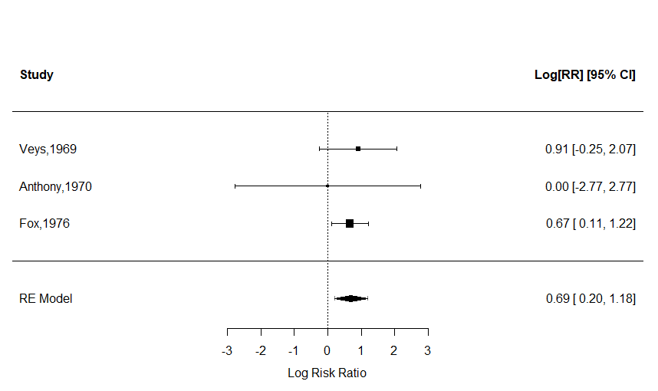

#### Figure 2: Random effect meta-analysis of RR for manufacture workers compared to non-manufacture workers

The risk of the BC onset by age and sex was informed through the calibration and is reported in the relevant section. Because the individual risks were informed through different sources which did not consider correlations between the relevant risk factors, re-calibration of the individual RR was necessary (see the calibration section).

## Other risk factors not included in the model

HSE 2018 does not contain any information about environmental carcinogens. A review on epidemiology of BC identifies exposure to arsenic in drinking water as a cause of BC1. There is no data that certain regions in England have higher risk of arsenic exposure in drinking water than the others though one source reported that arsenic concentrations >10 μg L−1 were previously measured in 5% of private water supplies. According to Public Health England, there is no risk of high content of arsenic in drinking water in England and so this risk factor was currently not included into the model 6.

## Modelling Changes in Phenotypic Characteristics by Age

Several of the characteristics included in the baseline modelled population will change as a person ages. These include EQ-5D and smoking status. Accurate modelling of individual level changes in these factors is extremely complex, but a simple set of methods was sought in order to be able to approximate changing risk and health benefits over time. While occupational exposure is also likely to change and risks may be cumulative over time, it was considered as a binary risk factor in the model because of lack of evidence on the dynamics of occupational exposure among the population in England and RR of occupational exposure after the retirement age.

### Smoking

Data from HSE 2018 indicates that the number of current smokers reduces by age, whilst the number of former smokers increases, indicating that there is a general trend for smoking cessation from the age of 30. This is supported by ONS data demonstrating that the proportion of current smokers in England has fallen significantly, and that those aged 25 to 34 years had the highest proportion of current smokers in the UK (19.0%). It is therefore assumed that no individuals who were surveyed as non-smokers in HSE 2018 would start smoking after the age of 30. The probability to remain a smoker after one year will be based on the estimated number of quitters (self-reported) per 100,000 smokers (from April 2020 to March 2021) according to the data of NHS digital: 0.0167 the estimated probability to quit smoking after one year and 0.9833 the estimated probability to remain a smoker.7 While modelling smoking cessation is much more complex and dynamic, we will need to use this simplified approach for project feasibility.

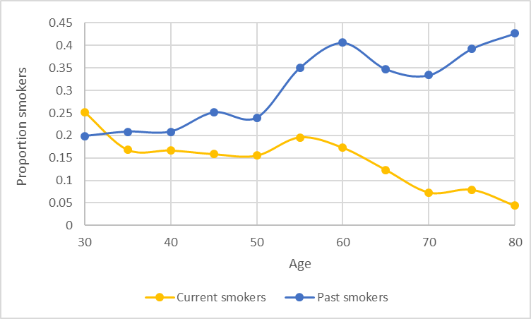

#### Figure 3: The proportion of current and former smokers by age in the HSE 2018 population 8

### EQ-5D

EQ-5D decreases with age, therefore annual age decrements were applied to each individual’s baseline EQ-5D score reflecting their current age in the model, compared with their baseline age. It was assumed that age-related decrements were constant over time. The size of this decrement was calculated using data from a study that pooled several years of HSE data to estimate general population values of EQ-5D by age. 9 Annual age decrement was calculated as the difference between EQ-5D score at ages 80-84 and 30-34, divided by 50, which resulted in a change of -0.00432 (95% CI: -0.00460; -0.00404) for each additional year of age. This process was used both to reduce EQ-5D as population ages beyond their surveyed age, and to increase EQ-5D in the cohort version of the model where individuals all start at age 30, which may be considerably younger than their surveyed age. EQ-5D at younger ages was constrained to a maximum of 1.

## Reconstructing population of England for model calibration and analysis

The model was set up to enable a single-aged cohort to be modelled, in order to answer cost-effectiveness questions. A starting age of 30 was chosen, as incidence of bladder cancer among those younger than 30 years is close to negligible 10. The cohort was created by artificially setting the ages of all individuals from HSE 2018 to 30. At the same time, adjustments were made to individual EQ-5D to reflect the change in age, based on the methods described above. Summary statistics for this population are shown in Table 4. The cohort was modelled over their lifetime to provide estimates of the parameters in the calibration (see the section on the model calibration).

For resource use questions, it is essential that the baseline population should represent the current population of England, i.e. a multi-aged cohort. In theory, this can be approximated using the HSE 2018 population with survey weights (Table 4). Because baseline individuals start at a range of different ages, it would be necessary to simulate a starting health state for each individual, rather than assuming all individuals were without cancer. This functionality has not yet been added to the model, but will be available in future model versions.

The all-England population will likely differ from the population in Yorkshire by their phenotypic characteristics, including smoking prevalence, age, and occupational exposure (Table 4). As it is possible to see from Table 4, the population in Yorkshire on average have higher proportion of current smokers, manufacture workers, and low-income individuals (IMD =5). While for the purpose of this analysis, the model needs to represent the population of Yorkshire, the population of this region in the HSE is too small to be representative, in particular, since the intervention affects only the current and past smokers. Thus, the iterative proportional fitting will be used to re-assign the weights to each person to reconstruct the Yorkshire population by a proportion of manufacture workers, smoking status, and IMD.

#### Table 3: Summary statistics for the model population at baseline, for multi-aged and single-aged cohorts from HSE 2018

|  |  |  |  |  |  |
| --- | --- | --- | --- | --- | --- |
| Characteristic | Mean (HSE 2018) | Standard Deviation | Weighted Mean at Multi-Aged Cohort Model Start, England | Weighted Mean at Single-Aged Cohort Model Start (Age 30), England | Weighted Mean for Yorkshire population (Age 30) |
| Age (years) | 55.99 | 15.78 | 54.84 | 30 |  |
|  | **Number in HSE 2018** | **Percentage in HSE 2018** | **Weighted Percentage (Multi-Aged Cohort)** | **Weighted Percentage Single-Aged Cohort)** | **Weighted Percentage for Yorkshire population** |
| Male | 3110 | 44.9% | 44.9% | 44.9% | 47.2% |
| Ethnicity: White | 6078 | 87.7% | 87.7% | 87.7% | 86.3% |
| Ethnicity: Asian | 478 | 6.9% | 9.0% | 9.0% | 8.2% |
| Ethnicity: Black | 201 | 2.9% | 2.9% | 2.9% | 2.7% |
| IMD1 | 1366 | 19.7% | 19.7% | 19.7% | 10.9% |
| IMD2 | 1493 | 21.6% | 21.6% | 21.6% | 22.0% |
| IMD3 | 1466 | 21.2% | 21.2% | 21.2% | 17.2% |
| IMD4 | 1398 | 20.2% | 20.2% | 20.2% | 20.7% |
| IMD5 | 1205 | 17.4% | 17.4% | 17.4% | 29.2% |
| Current Smoker | 1034 | 14.9% | 14.9% | 14.9% | 15.9% |
| Former Smoker | 2126 | 30.7% | 30.7% | 30.7% | 29.0% |
| Manufacture workers | 998 | 14.4% | 13.1% | 13.1% | 16.5% |

## Model population size

The size of population to model was defined by the standard error around the predicted mortality by age and sex (not to exceed 5% for each 5-year age group). The calculated minimum model population size is 1.3 mln. people (if general population is simulated).

# Natural History of Bladder Cancer

The natural history module of the model (Figure 1) relies upon: (a) the cancer onset, (b) cancer growth, and (c) the probability distributions to be in each health state based on a tumour size.

## Probability of cancer onset

The cancer onset is dependent on age, sex, occupation, and smoking status. For binary characteristics (current smokers, former smokers, and manufacture workers), the individual value was considered to be 1 for an individual possessing those characteristics, and 0 for an individual not possessing the characteristics, with the population mean value representing the proportion of current smokers in the population.

Considering non-linear relationship between the age and the incidence of BC (Figure 4), the relationship between the parameters and the risk of cancer onset will be modelled using the multiplications of the RR (where smoking and manufacture workers statuses are based on published data while risks for age and sex parameters are calibrated). The risk by age is accessed as:

where age_30y – risk of BC onset for 30 years old.

The relative risks impacting disease onset by demographic factors will be multiplied to a probability of BC onset for 30-year-old non-smoking non-manufacture worker female.

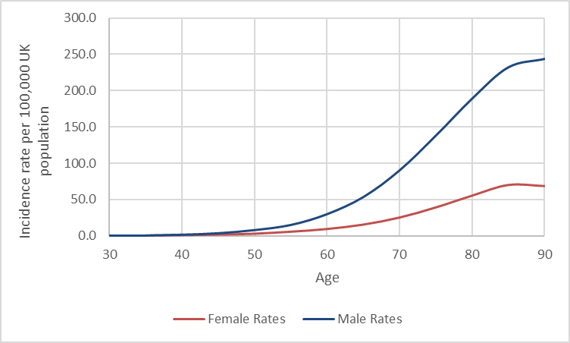

#### Figure 4: CRUK data on incidence of BC per 100,000 population for males and females (2016-2018)10

## Probability of disease progression

For any patients who had a BC onset, a type of the disease pathway is sampled. For those who follow a low-risk pathway, a probability to transit to the high-risk pathway is calibrated. The prior for this parameter is based on the assumption considering the inputs from clinical experts and published sources, since no direct evidence informing this probability is available. Linton et al (2013) in a study on low-risk patients with the median follow-up of 61 months (IQR 24–105) recorded progression and then death of 2.4% of patients. If uniform distribution for the progression rate over 5 years is assumed, it would mean that at least 2.4% of patients progress over five years or 0.48% annually. Considering the uncertainty in this value, it was used as a prior in the model calibration and did not parameterise the model directly. It was assumed that patients with diagnosed low-risk BC do not progress during the surveillance (the first year after diagnosis). Their probability to progress to after-surveillance period is equal to the joint probability of cancer recurrence and a probability of progression from low-to high-risk cancers.

For the high-risk pathway, the stage allocation was conducted probabilistically by sampling the time till reaching each Stage from a distribution with the fixed mean. The time will be randomly drawn from a Weibull distribution, with considerations for the defined mean (, calibrated shape (k), and calculated scale (lambda).

The mean time from cancer onset to the disease state will be based on the median time retrieved from the literature based on the clinical experts’ elicitation (i.e. assuming equality of the mean and the median)11, Table 4. The abstract reporting the time of progression between different stages across different cancers based on consensus methodology (RAND/UCLA modified Delphi panel method) was the only source found to inform the progression of undiagnosed BC.

#### Table 4: Median time of BC progression reported by Broder et al (2021)

|  |  |  |
| --- | --- | --- |
| Median time of BC progression: | Median and range | |
| Stage I to Stage II | | 3 (1-7) |
| Stage II to Stage III | | 2 (1-5) |
| Stage III to Stage IV | | <1(<1-4) |

## Recurrence

According to the same study and the clinical experts, low risk BC has a high recurrence rate. Linton et al (2013) informed that during 13.5 months of the follow up 28.5%, 95% CI(25.3–31.9) patients had a recurrence of low risk cancer12. In the BOXIT trial13 the recurrence rate of NMIBC was > 8 times more common than was progression to MIBC. Linton et al (2013)12 also report that the probability of developing recurrence with low-risk BC was 0.285 with 13 months of the follow up. In the base-case model the cancer recurrence is not modelled since the incidence reflects only the primary cancers.

The scenario analysis will consider additional costs and utility decrements related to recurrence of low-risk BC when screening is modelled, since screening is going to identify cancers that are not going to progress to high-risk BC. Thus, the annual probability of recurrence will be used as a direct parameter in the model (0.285 (0.253-0.319))12 to define a proportion of patients bearing higher costs and lower utilities due to repeated condition.

# Calibration

Calibration is necessary to inform the unobserved parameters or transitions. In this model calibration was applied for some of the RR and for the natural history disease parameters. The RR of cancer for manufacture workers resulted in a similar predictions of risk in the population over their lifetime (the mean predicted risk was 1.96 vs 1.99 in the published sources). Though, for the smoking status, the used RR (see the section “Risk factors included in the model”) resulted in different lifetime risk prediction. This means that an application of the RR at the level of the transitions from no cancer to cancer onset did not translate into equivalent relative risk of BC because of cross-interaction among the parameters, so values had to be adjusted through calibration.

## Relative risk calibration

A simple iterative process to calibrate the RR for current and former smokers was chosen which incorporated the following steps:

1. The smoking cessation rate was set to zero in the model.

2. The model was run for 200 sets of individuals in HSE 2018 population using a starting set of the RR used from the published sources (see the section “Risk factors included in the model”).

3. Following model running, the weighted incidence of BC in individuals with and without each characteristic was calculated and a modelled relative risk of BC calculated.

4. Modelled relative risk was compared against the target (published) relative risk for each characteristic. Multipliers were calculated as target relative risk/modelled relative risk.

5. Multipliers were applied to the starting set used for the last set of model runs, to create a new starting set of relative risks for each characteristic.

The mean RR for past smokers was 2.174497 instead of 2.04 in published sources; the RR for current smokers was 5.997746 instead of 3.47 in published sources.

## Natural History of bladder cancer calibration

The model was calibrated with the update on the calibration approach based on the outcomes of the first calibration attempt (see the Appendix C).

### Calibration parameters

The following parameters related to the NHD were calibrated:

* Probability of BC onset (for 30-year-old females who are non-smokers and not manufacture workers)
* Probability to have a low-grade tumour at the time of BC onset
* Coefficients of the independent variables (male sex vs female sex and age increase compared to age 30 years) in the equation defining the individual probability of BC onset: βage, βsex
* Probability to become a symptomatic patient at the year of cancer onset and probability to become a symptomatic patient by time since onset for high-risk BC
* Annual probability to become a symptomatic patient for low-risk BC
* An annual decrements in symptomatic diagnosis for low-risk and high-risk elderly population group (older than 67 years old)
* Shape parameters of tumour progression for the Weibull distributions (3 parameters).

Second stage of the calibration:

* A probability to transit from low-grade to the high-grade pathway within 1 year [prior is used in the first step of the calibration].

### Calibration targets

Considering that there is currently no BC screening in England, the model was calibrated to the current epidemiological data:

* Incidence of high-risk BC in England by age and sex in 2016-2018 (Figure 8)
* Incidence of high-risk BC by stage (stage distribution at diagnosis)
* Incidence of low-risk BC.

### Incidence of high-grade BC: total and by stage

Age-specific incidence rates for HRBC for males and females registered in 2016-2018 is reported by the Cancer Research UK 10. Considering that no data on BC stage distribution at diagnosis by age and sex is found for England in current publicly available sources, we will consider that incidence of HRBC by stage follows the pattern of the age- and sex-specific total incidence rates. The international data (Table 6) show some (but not significant) variations in TNM stage distribution by sex (males more frequently diagnosed in pT4 and less pT3 in the studies included in the systematic review by Dobruch et al (2016).14 Though there is no consistency in the effect of sex on stage distribution at diagnosis and no data on the impact of age on the stage distribution was identified. The NHS data report the following proportion of patients diagnosed at different stages: Stage 1- 32.5%; Stage 2 - 19.4%; Stage 3 - 9.5%; Stage 4 - 7.3%; missing stage -31.3%. The comparison of these data to the reporting from the systematic review by Dobruch et al (2016), leads to the conclusion that patients with missing stage mainly include the patients in the advanced conditions (43-51% of patients are classified as pT3 -pT4).14 Because of no data on the distribution of BC cases between Stages 3 and 4, it was assumed that the missing stage is distributed equally between the Stage 3 and 4. While the calibration included the incidence by stage as individual targets, considering uncertainty, the final fit only included the combined calibration target “advanced BC” (i.e. Stage 3,4 cases, and the missing stage cancers). The calibration targets BC incidence and BC incidence by stages are reported in the Table 7.

#### Table 5: Distribution of bladder cancers by stage at diagnosis (percentages)14

|  |  |  |  |  |  |  |  |  |  |  |  |
| --- | --- | --- | --- | --- | --- | --- | --- | --- | --- | --- | --- |
|  |  | Sample | Country | T0 | Ta | Tis | T1 | T2 | T3 | T4 |  |
| Kluth et al15 | male | 6497 | Multi-country multicentre | 5.6 | 4.3 | 8.2 | 15 | 24 | 31 | 12 |  |
|  | female | 1605 |  | 5.3 | 4.5 | 7.4 | 11 | 25 | 37 | 9.5 |  |
| Soave et al16 | male | 398 | Germany, single centre | 9.8 | 4.8 | 10.6 | 14.1 | 17.1 | 26.6 | 17.1 |  |
|  | female | 119 |  | 10.1 | 2.59 | 4.2 | 8.4 | 23.5 | 34.5 | 16.8 |  |
| Otto et al 17 | male | 507 |  | 29.5 | | | | 26.8 | 32.6 | 11.1 |  |
|  | female | 1976 | Germany, multicentre | 24.7 | | | | 27.6 | 38.8 | 8.9 |  |

#### Table 6: Incidence of high-grade bladder cancers by stages per population alive

|  |  |  |  |  |  |  |  |  |
| --- | --- | --- | --- | --- | --- | --- | --- | --- |
| Age, lower bond | Incidence rate in females | Incidence rate in males | Females | | | Males | | |
| Stage 1 | Stage 2 | Stage 3,4 | Stage 1 | Stage 2 | Stage 3,4 |
| 30 | 0.000002 | 0.000003 | 6.5E-07 | 3.89E-07 | 9.62E-07 | 9.75E-07 | 5.83E-07 | 1.44E-06 |
| 35 | 0.000004 | 0.000006 | 1.3E-06 | 7.77E-07 | 1.92E-06 | 1.95E-06 | 1.17E-06 | 2.89E-06 |
| 40 | 0.000010 | 0.000017 | 3.25E-06 | 1.94E-06 | 4.81E-06 | 5.52E-06 | 3.3E-06 | 8.17E-06 |
| 45 | 0.000018 | 0.000037 | 5.85E-06 | 3.5E-06 | 8.66E-06 | 1.2E-05 | 7.19E-06 | 1.78E-05 |
| 50 | 0.000030 | 0.000081 | 9.75E-06 | 5.83E-06 | 1.44E-05 | 2.63E-05 | 1.57E-05 | 3.89E-05 |
| 55 | 0.000058 | 0.000151 | 1.88E-05 | 1.13E-05 | 2.79E-05 | 4.91E-05 | 2.93E-05 | 7.26E-05 |
| 60 | 0.000095 | 0.000300 | 3.09E-05 | 1.85E-05 | 4.57E-05 | 9.75E-05 | 5.83E-05 | 0.000144 |
| 65 | 0.000156 | 0.000535 | 5.07E-05 | 3.03E-05 | 7.5E-05 | 0.000174 | 0.000104 | 0.000257 |
| 70 | 0.000253 | 0.000902 | 8.22E-05 | 4.92E-05 | 0.000122 | 0.000293 | 0.000175 | 0.000434 |
| 75 | 0.000392 | 0.001379 | 0.000127 | 7.62E-05 | 0.000188 | 0.000448 | 0.000268 | 0.000663 |
| 80 | 0.000555 | 0.001887 | 0.00018 | 0.000108 | 0.000267 | 0.000613 | 0.000367 | 0.000907 |
| 85 | 0.000701 | 0.002317 | 0.000228 | 0.000136 | 0.000337 | 0.000753 | 0.00045 | 0.001114 |
| 90 | 0.000686 | 0.002432 | 0.000223 | 0.000133 | 0.00033 | 0.00079 | 0.000472 | 0.001169 |
| 95 | 0.000686 | 0.002432 | 0.000223 | 0.000133 | 0.00033 | 0.00079 | 0.000472 | 0.001169 |

#### Incidence of low-risk bladder cancer

Incidence and incidence by stage reported by the Office for National statistics and Cancer Research UK reports the number of BC cases significantly lower than the National Cancer Registration and Analysis Service (NCRAS) Data Repository, NHS Digital. This is because, according to the clinical experts, the national statistical data includes only high-risk BC. To estimate the incidence of low-risk BC, we used the NCRAS Data Repository that reports the total number of BC cases registered in 2019 (18,595 cases), and subtracted from it the number of low-risk cancers reported by the CRUK, 2019 (8,951 cases) to calculate the incidence of low-risk BC. The ratio of low-to high-risk BC was used to calculate the estimates incidence of low-grade cancers by age and sex (assuming the same age- and sex- trend as for high-risk BC considering no data to inform otherwise) (Table 8).

#### Table 7: Incidence of low-grade bladder cancers by stages per population alive

|  |  |  |
| --- | --- | --- |
| Age, lower bond, years | Rate of low-risk cancers, females | Rate of low-risk cancers, males |
| 30 | 2.15484E-06 | 3.23226E-06 |
| 35 | 4.30969E-06 | 6.46453E-06 |
| 40 | 1.07742E-05 | 1.83162E-05 |
| 45 | 1.93936E-05 | 3.98646E-05 |
| 50 | 3.23226E-05 | 8.72711E-05 |
| 55 | 6.24904E-05 | 0.000162691 |
| 60 | 0.000102355 | 0.000323226 |
| 65 | 0.000168078 | 0.000576421 |
| 70 | 0.000272588 | 0.000971834 |
| 75 | 0.000422349 | 0.001485764 |
| 80 | 0.000597969 | 0.002033094 |
| 85 | 0.000755272 | 0.002496386 |
| 90 | 0.000739111 | 0.002620289 |
| 95 | 0.000739111 | 0.002620289 |

#### Mortality with bladder cancer in England

Mortality of BC in England by age and sex in 2016-2018 (Figure 5) was used for the validation of the calibrated model18.

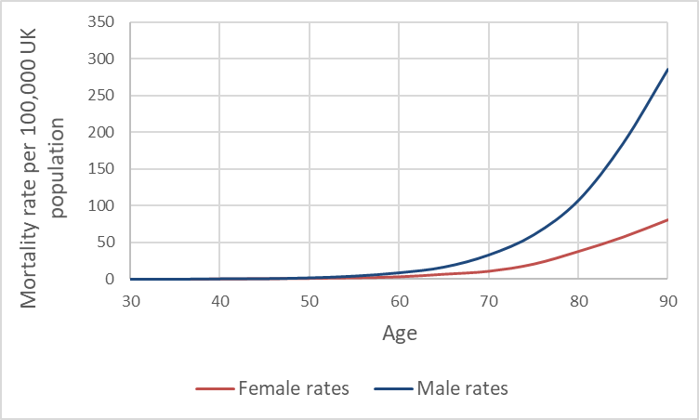

#### Figure 5: Mortality of BC per 100,000 population for males and females (2016-2018)

### Calibration approach

#### Background

The approach to generating parameters in model calibration can be Bayesian or non-Bayesian. Non-Bayesian methods aim to improve the model’s predictive power by identifying the optimal set of calibration parameters for which the model reproduces the calibration target19. In contrast, a Bayesian calibration seeks to generate a posterior distribution of calibration parameters and model outputs, conditional on the calibration target19 20. This means that if non-Bayesian calibration is applied, the uncertainty around the NHD parameters will not be fully explored and integrated into the probabilistic sensitivity analysis, and so may introduce biases into the modelling outputs.

Metropolis-Hasting algorithm (MHA) is one of the most common used approaches in calibration of the NHD models. The calibration theory says that if the MHA is long enough it should explore fully the parameter space. This approach though is computationally expensive since microsimulation of the population with rare events (such as cancer) requires a substantial running time. With the limited processing time, there is a risk that the parameter space is not adequately explored. That is to say that one cannot be sure that if the convergence is achieved, there are no other alternative acceptable parameter regions. Statistician Ben Lambert suggests that MHA (a) is not efficient when there are multiple calibration targets especially in the presence of any correlations (b) has a risk of false convergence (since requires unlimitedly long runs and is very tricky to understand whether the convergence was reached).Thus, MHA may produce parameters with a risk of biases (similar to non-Bayesian ways) and risks that the parameter space is not properly explored. To minimize the risk, the two-step approach with the Bayesian algorithm (Step 2) was run with multiple initial sets (n=5) identified on Step 1.

#### Approach

The approach applies a two-step calibration process:

**Step 1. Random (non-Bayesian) calibration to define the parameter space**

Firstly, parameter space was defined by running a random calibration with the Latin Hypercube Sample. Latin Hypercube Sample generates a near-​random sample of parameter values from a multidimensional distribution. The model was run with the population size of around 700,000 (100 HSE populations).

**Goodness of file (GOF)**: likelihood. Since the model is run as population of the same age, the number of events at each age are dependent and represent events in time. Thus, likelihood was calculated as lifetime incidence (e.g. Likelihood of BC incidence for females).

**Acceptance criteria**: The parameters’ sets with the difference in GOF of less than 5% from the best-fit parameters were included what results in 5 sets of parameters.

**Outcome**: parameter sets to be used as initial sets in the calibration. Understanding with how many initial parameters’ sets the calibration process should start.

**Step 2. MHA algorithm (Bayesian calibration).**

The MHA with the number of initial parameter sets identified at the Step 1 was used. The parameters were sampled from normal distribution with the maximum step size (epsilon) of 20% of each parameter value at the first iteration.

The transition probabilities were restricted to be sampled in the range of zero to one. In addition, a weak prior was set up for transition from low-risk to high-risk BC based on the published data and strong priors were set up for:

* A symptomatic presentation decreases after the age 67 years for both low-risk and high-risk BC;
* Probability to be diagnosed annually with low-risk BC is no more than 40%;
* Probability to be diagnosed the first year one had an onset of high-risk BC is no more than 50%;
* The shape parameters defining the stage allocation in Weibull distribution do not exceed one.
* The relative risk for males does not exceed 10 and the relative risk for each year of age does not exceed 2.

As the algorithm converges the maximum step size was reduced by 60% of the original value. The values were set by tuning the algorithm to achieve the 10% acceptance rate after the warmup period (around 300 calibration runs).

The proposal parameter set in calibration was always accepted if the proposal parameter had higher likelihood than the current parameter set; in addition, 0.5% of calibration runs with lower likelihoods after the warmup period were accepted. The five chains of the MHA were run. For each calibrated parameter (the 2528 sets of parameters), the means and the standard deviations were calculated. The final calibrated parameters were sampled from truncated normal distributions (for probabilities, which were restricted from zero to one) or from normal distribution (for all the other parameters).

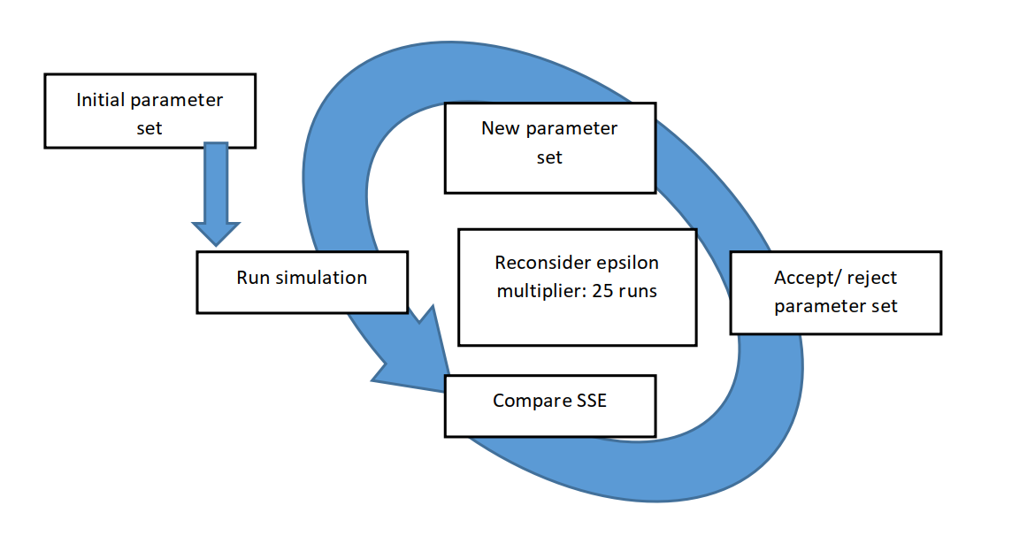

#### Figure 6: Metropolis-Hastings algorithm used to calibrate model parameters

### Calibration outcomes, fit and validation

The calibration allowed to achieve a good fit to low-risk BC and total high-risk BC, stage 1, stage 2, and stage 3 and 4 combined for both males and females but only up to the age of 80 years.

*Table 8: Calibrated parameters*

|  |  |  |  |
| --- | --- | --- | --- |
| **Parameter** | **Best fit parameters** | **Mean parameters** | **s.d. around the mean** |
| Probability of cancer onset | 0.00001012 | 9.84E-06 | 9.52E-07 |
| Probability to have low-risk BC at onset | 0.60213 | 0.651677 | 0.045879 |
| RR of increase of BC risk with each year of age | 1.12101 | 1.112449 | 0.007147 |
| RR of increase of BC risk with male sex | 3.253233 | 3.747427 | 0.865682 |
| Probability to be diagnosed (annually) with low-risk BC | 0.23704997 | 0.233519 | 0.066252 |
| Coefficient of increase in probability to be diagnosed with time since onset | 0.12112886 | 0.121018 | 0.007525 |
| Probability to be diagnosed at the year of onset for high-risk BC | 0.22854695 | 0.226649 | 0.002497 |
| Decrease in symptomatic presentation rate for high-risk BC (after age 67 years) | 0.9712 | 0.876201 | 0.092163 |
| Decrease in symptomatic presentation rate for low-risk BC (after age 67 years) | 0.97212 | 0.911635 | 0.072095 |
| Shape in the Weibull distribution for progression to stage 2 | 0.72250016 | 0.661739 | 0.055828 |
| Shape in the Weibull distribution for progression to stage 3 | 0.66778215 | 0.76643 | 0.121579 |
| Shape in the Weibull distribution for progression to stage 4 | 0.47116586 | 0.422597 | 0.088376 |
| Probability to progress from low-risk to high-risk BC (annual) | 0.0045 | 0.004399 | 0.000733 |

The example on the acceptance of the parameters by different chains is presented on the probability of BC onset (Figure 7a) and the RR of increase of BC risk with each year of age (Figure 7b).

*Figure 7a: Acceptance of the parameter “probability of BC onset”*

#### Figure 7b: Acceptance of the parameter “RR of increase of BC risk with each year of age”

In the model, 80% of patients in the model who had BC onset get diagnosed, while others died from other causes. Most of the patients progressed to stages 2-4 within 3 years (Table 9) with 3% of patients taking more than 20 years to progress to stage 4 from cancer onset.

*Table 9: Percentage of population progressed from onset time (stage 1) to other stages*

|  |  |  |  |
| --- | --- | --- | --- |
| Time limit | Onset to stage 2 | Onset to stage 3 | Onset to stage 4 |
| Less than 1 year | 26.4% | 7.1% | 3.5% |
| Less than 3 years | 62.2% | 38.9% | 29.2% |
| More than 10 years | 5.5% | 11.7% | 16.1% |
| More than 20 years | 1.2% | 2.3% | 3.1% |

In the data used to calibrate the model11, the range from BC onset to progression to Stage 2 was reported as 1-7 years. In the model, 89% of patients progressed to stage 2 within this time (Table 10).

*Table 10: Percentage of population progressed from onset time (stage 1) to other stages*

|  |  |  |
| --- | --- | --- |
| Progression to stage | The range of the time to stage reported in the qualitative study of Broder et al (2021)11 | The model predictions of the proportion of patients who progress within this indicated range |
| to Stage 2 | 0-7 years | 89.4% |
| to Stage 3 | 0-12 years | 90.3% |
| to Stage 4 | 0-16 years | 93.2% |

The model had a good fit to the total incidence, low-risk incidence and incidence by stage 1,2, and 3 and 4 combined for both males and females. The model is also well-validated to the mortality data for males and females (Figure 8.1- 8.12).

*Figure 8: Fit of the model predictions (red) to the data (black)*

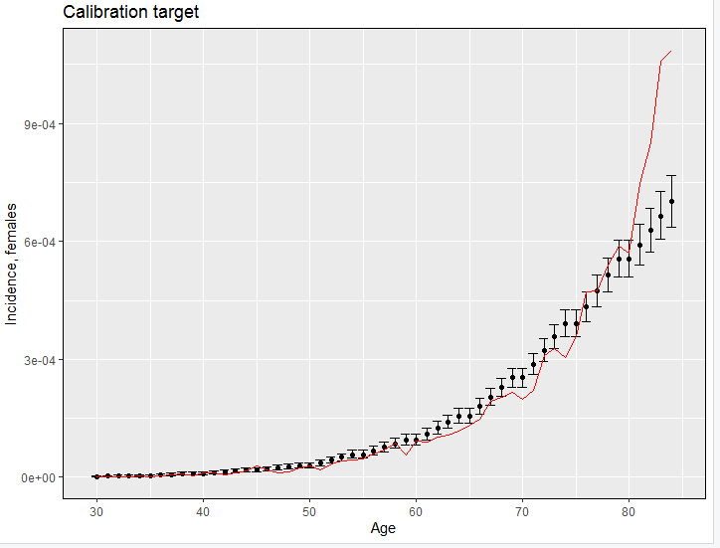

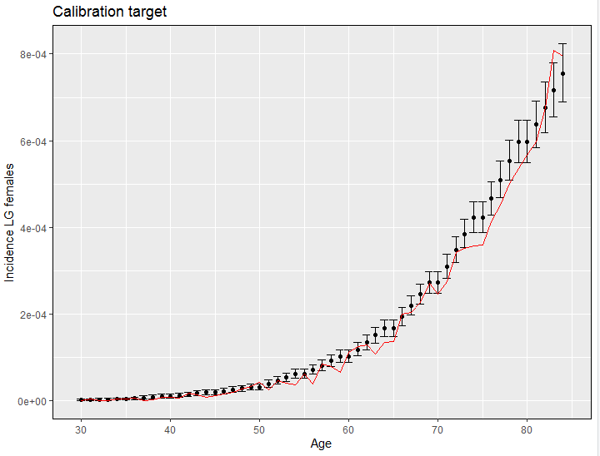

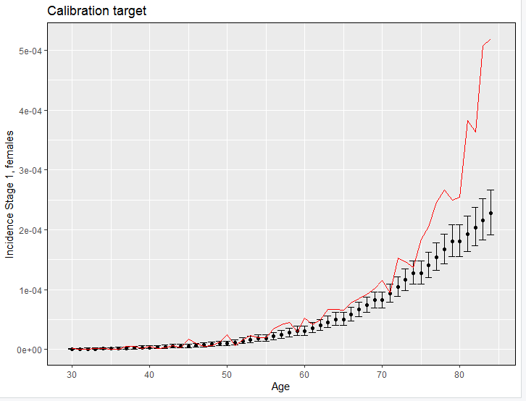

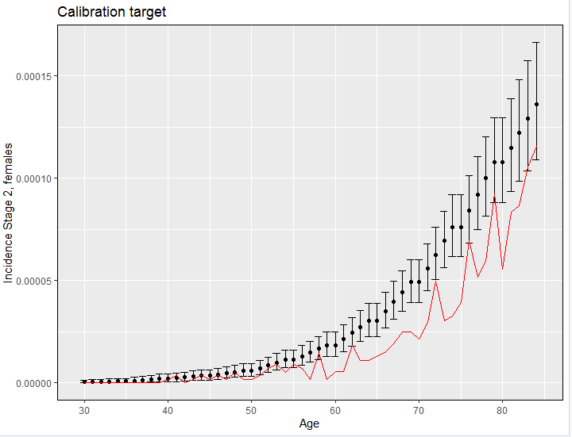

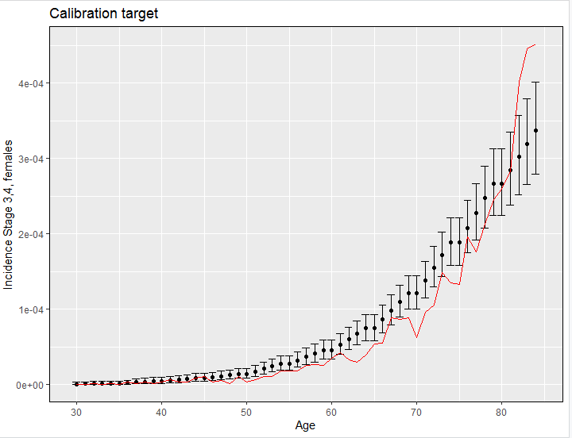

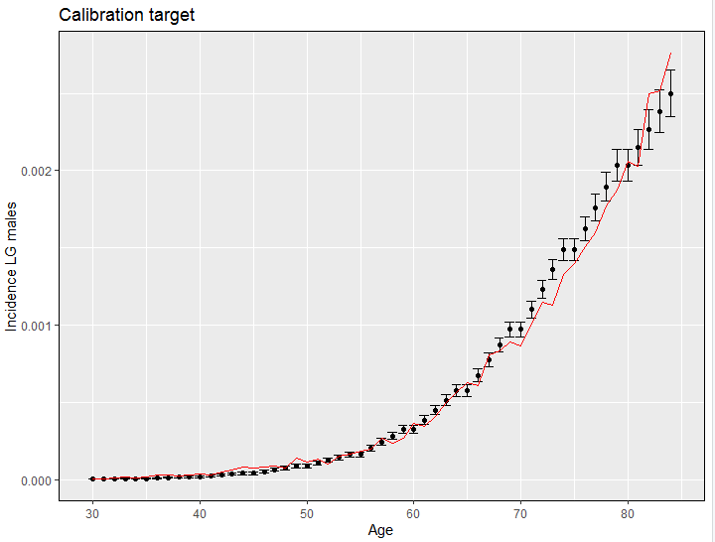

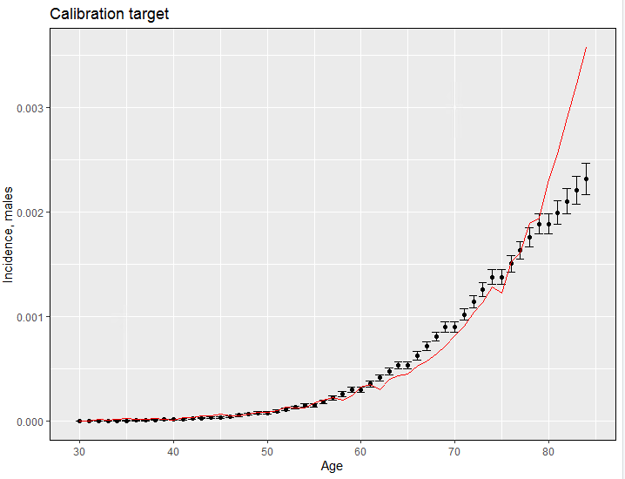

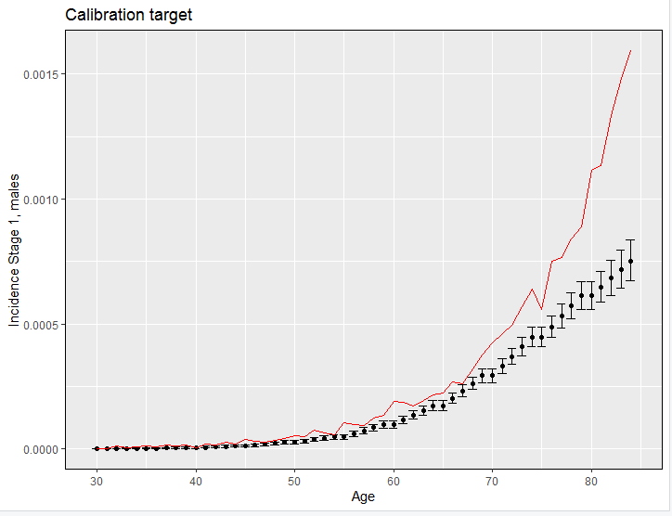

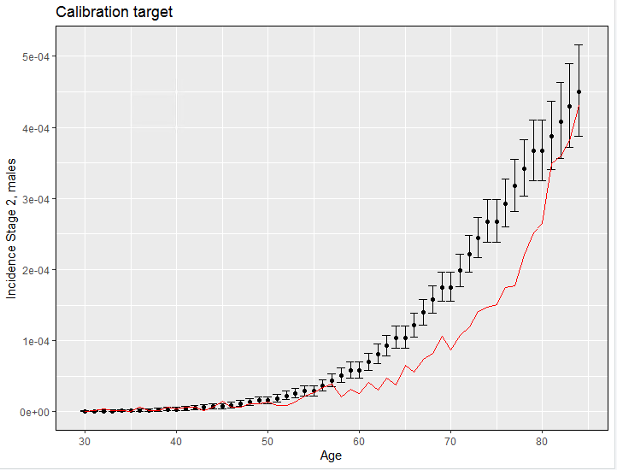

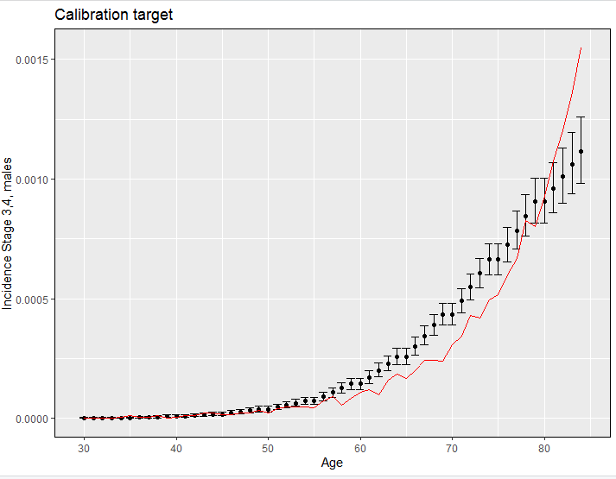

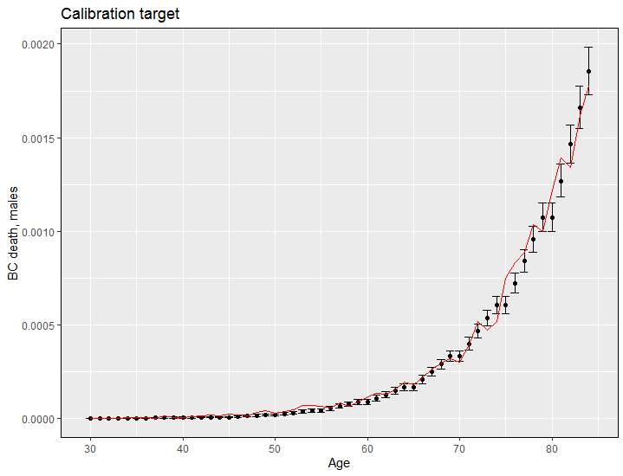

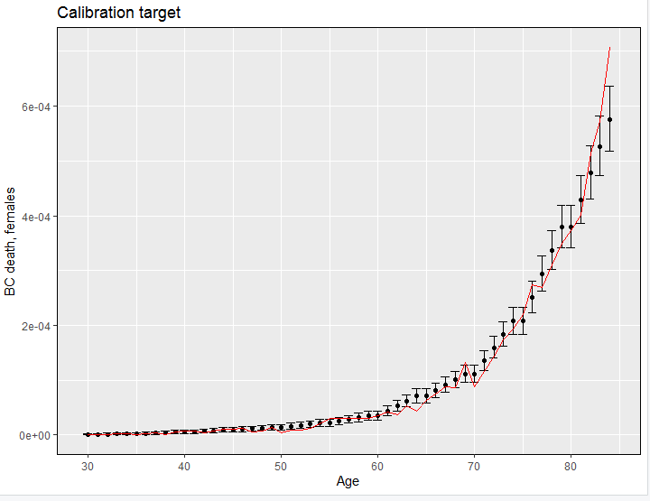

## Survival

Individuals can either die from BC or from other causes. Survival following BC diagnosis is known to vary by age, sex, cancer stage, and time since diagnosis21. While there are number of sources reporting 1-, 5- , and 10-year survival from BC, these data are incomplete, and so a combination of sources was necessary to assess the BC survival including different factors. It was assumed that anyone surviving for ten years post-diagnosis was cured and would have no further risk of death from BC.

One and five year net BC survival data by age group, sex and stage is available from the Office for National Statistics (ONS) based on data from adults diagnosed between 2013 and 2017 in England 21 (Table 8). Though, the data for some subgroups, in particular 5-year survival by age among women diagnosed at stage 4 was missing. ONS data do not report 10-year survival. To assess 10-year survival, the ratio between 5- and 10-year survival among males and females was calculated from CRUK data in 2013-201722. This is presented by sex, but not by age or stage, and is fairly similar to the ONS values for year one and five survival over all ages and stages. The calculated ratio was applied to 5-year survival by age to assess 10-year survival by age (Table 11).

#### Table 11: Net one and five year survival by age group, sex and stage for 2013-2017 from ONS 21 and 10-year survival from CRUK22

|  |  |  |  |  |  |  |  |  |  |  |  |
| --- | --- | --- | --- | --- | --- | --- | --- | --- | --- | --- | --- |
|  | Age group | 1-year survival | Net survival lower CI | Net survival upper CI | Age group | 5-year survival | Net survival lower CI | Net survival upper CI | 10-year survival | Net survival lower CI | Net survival upper CI |
| Stage 1 | | | | | | |  |  |  |  |  |
| Men | 15-44 | 97.2 | 93.9 | 100.5 | 15-54 | 84.7 | 80.3 | 89.1 | 72.9 | 69.1 | 76.7 |
|  | 45-54 | 97.9 | 96.6 | 99.3 | 55-64 | 87.6 | 85.0 | 90.2 | 75.4 | 73.2 | 77.7 |
|  | 55-64 | 98.0 | 97.2 | 98.8 | 65-74 | 81.2 | 79.1 | 83.4 | 69.9 | 68.1 | 71.8 |
|  | 65-74 | 96.5 | 95.8 | 97.2 | 75-99 | 69.7 | 66.5 | 72.9 | 60.0 | 57.3 | 62.8 |
|  | 75-99 | 92.7 | 91.8 | 93.6 |  |  |  |  |  |  |  |
| Women | 15-44 | 92.3 | 82.3 | 102.4 | 15-44 | : | : | : |  |  |  |
|  | 45-54 | 97.6 | 94.7 | 100.4 | 45-54 |  |  |  |  |  |  |
|  | 55-64 | 97.8 | 96.3 | 99.4 | 55-64 | 86.5 | 81.8 | 91.2 | 80.8 | 76.4 | 85.2 |
|  | 65-74 | 94.7 | 93.2 | 96.2 | 65-74 | 81.0 | 77.2 | 84.7 | 75.7 | 72.1 | 79.2 |
|  | 75-99 | 86.5 | 84.6 | 88.3 | 75-99 | 67.6 | 62.9 | 72.4 | 63.2 | 58.8 | 67.7 |
| Stage 2 | | |  |  |  |  |  |  |  |  |  |
| Men | 15-44 | 80.1 | 67.0 | 93.2 | 15-54 | 57.9 | 50.6 | 65.2 | 49.8 | 43.6 | 56.1 |
|  | 45-54 | 85.0 | 80.6 | 89.4 | 55-64 | 54.7 | 50.3 | 59.2 | 47.1 | 43.3 | 51.0 |
|  | 55-64 | 85.6 | 83.2 | 88.1 | 65-74 | 54.0 | 50.9 | 57.1 | 46.5 | 43.8 | 49.2 |
|  | 65-74 | 80.6 | 78.8 | 82.4 | 75-99 | 34.0 | 31.1 | 36.9 | 29.3 | 26.8 | 31.8 |
|  | 75-99 | 64.3 | 62.7 | 66.0 |  |  |  |  |  |  |  |
| Women | 15-44 | 52.2 | 32.4 | 72.0 | 15-44 | : | : | : |  |  |  |
|  | 45-54 | 78.4 | 70.7 | 86.1 | 45-54 | 52.3 | 41.3 | 63.3 | 48.9 | 38.6 | 59.2 |
|  | 55-64 | 78.2 | 73.0 | 83.3 | 55-64 | : | : | : |  |  |  |
|  | 65-74 | 72.6 | 69.2 | 75.9 | 65-74 | 44.8 | 40.2 | 49.5 | 41.9 | 37.6 | 46.3 |
|  | 75-99 | 55.5 | 53.0 | 58.0 | 75-99 | 27.3 | 23.5 | 31.0 | 25.5 | 22.0 | 29.0 |
| Stage 3 | |  |  |  |  |  |  |  |  |  |  |
| Men | 15-44 | 81.1 | 64.7 | 97.5 | 15-54 | : | : | : |  |  |  |
|  | 45-54 | 83.4 | 75.1 | 91.7 | 55-64 | 51.5 | 43.1 | 59.9 | 44.3 | 37.1 | 51.6 |
|  | 55-64 | 78.2 | 72.5 | 83.8 | 65-74 | 48.0 | 42.4 | 53.7 | 41.3 | 36.5 | 46.2 |
|  | 65-74 | 75.5 | 71.9 | 79.1 | 75-99 | 31.8 | 26.5 | 37.1 | 27.4 | 22.8 | 31.9 |
|  | 75-99 | 59.8 | 56.1 | 63.4 |  |  |  |  |  |  |  |
| Women | 15-44 | 75.1 | 54.6 | 95.5 | 15-44 | : | : | : |  |  |  |
|  | 45-54 | 72.4 | 60.6 | 84.3 | 45-54 | : | : | : |  |  |  |
|  | 55-64 | 76.0 | 67.1 | 84.8 | 55-64 | 43.0 | 35.0 | 50.9 | 40.2 | 32.7 | 47.6 |
|  | 65-74 | 65.8 | 59.8 | 71.8 | 65-74 | 18.1 | 11.9 | 24.3 | 16.9 | 11.1 | 22.7 |
|  | 75-99 | 42.9 | 37.9 | 48.0 | 75-99 |  |  |  |  |  |  |
| Stage 4 | |  |  |  |  |  |  |  |  |  |  |
| Men | 15-44 | 47.9 | 33.7 | 62.1 | 15-54 | : | : | : |  |  |  |
|  | 45-54 | 44.9 | 37.6 | 52.1 | 55-64 | : | : | : |  |  |  |
|  | 55-64 | 42.3 | 38.1 | 46.5 | 65-74 | 14.2 | 10.4 | 17.9 | 12.2 | 9.0 | 15.4 |
|  | 65-74 | 43.0 | 40.4 | 45.7 | 75-99 | 15.4 | 12.9 | 18.0 | 13.3 | 11.1 | 15.5 |
|  | 75-99 | 28.3 | 26.3 | 30.3 | All ages |  |  |  |  |  |  |
| Women | 15-44 | 36.0 | 24.4 | 47.6 |  |  |  |  |  |  |  |
|  | 45-54 | 37.3 | 29.5 | 45.1 | All ages, women | 8.3 | 6.7 | 9.9 | 7.8 | 6.3 | 9.3 |
|  | 55-64 | 38.7 | 33.0 | 44.4 | All ages, men | 11.9 | 10.4 | 13.4 |  |  |  |
|  | 65-74 | 34.8 | 30.8 | 38.8 |  |  |  |  |  |  |  |
|  | 75-99 | 19.9 | 17.4 | 22.4 |  |  |  |  |  |  |  |

For the subgroups of the population with missing data, the survival was calculated by applying a ratio in annual survival in the target age group and the age group with available data. For example, five-year survival at Stage 4 for men younger than 55 years was calculated as the follows: the ratio of annual survival for men aged 55-64/age 45-54 is 0.94 and the ratio of annual survival for men age 55-64/age 15-44 is 0.88. Since the five-year survival among those aged 55-64 was 14.2, the calculated five-year survival among 45–54-year-old men was 14.2/ 0.94 = 15.07, and among 15–44-year-old men 14.2/ 0.88 = 16.08.

Considering that there was no survival data by age for women diagnosed at stage 4, the survival by age was calculated by applying a ratio in survival among males and females diagnosed at Stage 4. The proportion of population surviving annually (i.e. the survival probability between the years 1 and 5 and between the years 5 and 10) was assessed through exponential interpolation. An example of such interpolation is demonstrated at the Figure 9.

#### Figure 9: Annual survival probability among 15–44-year-old males diagnosed at Stage 1 Bladder cancer

Probability of dying due to BC was calculated from the survival data as follows:

BC_mort(age, sex, stage, year) = 1 – (BC_surv(age, sex, stage, year) / BC_surv(age, sex, stage, year-1))

It was assumed that the probability of dying from BC beyond ten years post diagnosis was 0.

## Mortality from other causes

The model assumes that there is no mortality from undiagnosed BC (i.e. no mortality in preclinical stage).

Individuals defined as a target screened population, such as smokers, are likely to be at a higher risk of mortality from other causes as well (e.g. lung and other cancers). Thus, it is important for other cause mortality to be correctly reflected in the model. To accurately reflect the mortality from other causes, the RR for non-BC mortality among smokers, former smokers, and never smokers were applied using the all-cause mortality data by age and sex and the data on relative risk of smoking status on all-cause mortality reported by the prospective study in the UK which recruited 1·3 million UK women in 1996–200123. The study reports that among ex-smokers who had stopped smoking permanently at ages 25–34 years or at ages 35–44 years, the respective relative risks were 1.05 (95% CI 1.00–1.11) and 1.20 (1.14–1.26) for all-cause mortality. For 12-year mortality, those smoking at baseline had a mortality rate ratio of 2.76 (95% CI 2.71–2.81) compared with never-smokers. We will assume the constant rate of the RR for the smoking compared to no -smoking considering a lack of quantitative data to inform the time trend based on smoking duration. This means that while the mortality will be age and sex specific, the model assumes that smoking status affects similarly other cause mortality as it does for the all-cause mortality. BC mortality will be subtracted from all-cause mortality to retrieve other-cause mortality.

1. The RR(no smoke/all pop) is = Rd.nsm / Rd. all-pop
2. Rd. all-pop = N Death all pop / Size all pop= (Nd.sm + Nd.past.sm + Nd.no.sm)/ Size all pop = (Rd.sm*Nsm + Rd.psm*Npsm + Rd.nsm*Nno.sm) / Size all pop

Where Rd.sm, Rd.psm, and Rd.nsm, Rc. all-pop – rate of death in current, past, no smoker, and all populations. Nsm, Npsm, Nno.sm – number of current, past, and no smokers.

From (1) and (2) and dividing both the nominator and denominator to Rd.nsm:

1. The RR(no smoke/all pop) is = Rd. all-pop/(RRsm/no.sm *Nsm + RRpsm/ no.sm *Npsm + Nnsm)

The calculated RR (OC death for no smoke/all pop) is 0.7547219.

# Symptomatic Presentation

The symptomatic pathway for BC patients as it is described by NICE, is presented on the Figure 10.

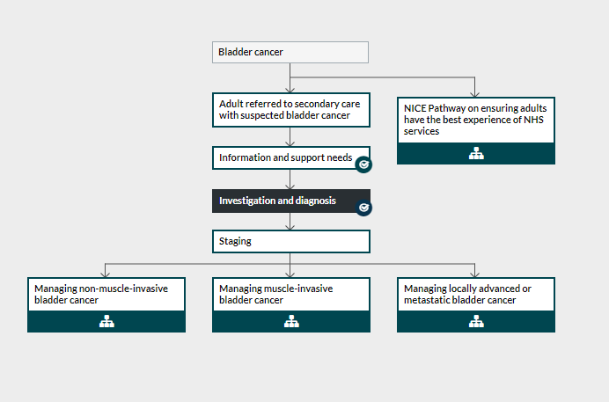

#### Figure 10: symptomatic pathway for BC patients.

For diagnostic pathway, the NICE guidelines state that computer tomography (CT) or magnetic resonance imaging (MRI) staging should be considered before trans urethral resection of bladder tumour (TURBT) if MIBC is suspected at cystoscopy. In practice, based on consultations with the clinicians, patients are commonly diagnosed by cystoscopy only. White-light-guided TURBT with one of photodynamic diagnosis, narrow-band imaging, cytology or a urinary biomarker test (such as UroVysion using FISH, ImmunoCyt or a NMP22 test) should be offered to people with suspected bladder cancer. Prospective national audit survey of cancer diagnosis however assessed that only a proportion of a symptomatic population is getting haematuria test, US scan, or blood test24.

In the model, probability to be diagnosed as a symptomatic patient was calibrated (See Natural History of BC Section). Patients who develop symptoms and get diagnosed accumulate costs and disutilities and have an annual probability to die from BC based on their age, sex, and time since diagnosis. The costs and utilities relevant for symptomatic presentation pathway are described in the relevant sections.

# Screening

As default the model simulates a single, one-off screening intervention: home urine dipstick test. The population with a positive screening test will get a cytology test and the US, and, if positive, the white-light-guided TURBT. The screened population will be modelled to reflect the population in the trial.

### Screening Eligibility and scenarios

The modelled population will be compatible to the population of the trial described as the Cohort 1 of the trial. The Cohort 1 suggests a one-time home-base screening among males and females aged 55-80 years old. The test to be used is The Roche Combur 5 HC test. Those verbally consenting will be asked to home self-test their urine up to 6 times over consecutive days for haematuria. The protocol plan assumes to invite 2,000 persons leading to the detection of 1-7 cancers and so will not be able to inform clinical outcomes.

In the model, the base case analysis will include a one-time screening at ages 65 years. The scenario analyses will assess cost-effectiveness of one-time screening among younger and older population (55 and 75 years old).

### Screening Uptake

In the base case (pre-trial) modelling 100% uptake with the screening test will be considered to assess the cost-effectiveness of the intervention under complete populational compliance. Differential uptake (40% as it is assumed in the trial) will be considered in the scenario analyses.

Similar to other cancer screening programmes, the uptake is likely to differ by age and sex, as well as deprivation, and ethnicity. Considering no data on screening uptake for homebase haematuria test, the impact of age, sex, and IMD will be considered to be identical to the home FIT used in colorectal cancer screening (MiMiC-Bowel model). The trial data on the uptake by age, IMD, and ethnicity will be incorporated upon the trial completion.

In the MiMiC-Bowel model an impact of different characteristics on screening uptake was informed through the FIT pilot. The English FIT pilot results included a multivariate analysis of adequate uptake which provided odds ratios for uptake by age group, sex, and deprivation (IMD quintiles) 25. This indicates that uptake is lower in males, older age groups, and more highly socioeconomically deprived groups. Model coefficients were calculated by taking the log of each odds ratio. Uptake in the reference group (male, age 59-64, IMD1 [least deprived], first screening round) was 53.6% . This information was used to calculate an intercept for the model using the formula: intercept = -LN((1/x)-1) where x = baseline uptake. The intercept was then adjusted to represent country-wide FIT screening. Odds ratios and model coefficients are shown in Table 10.

#### Table 9: Odds Ratios from Moss et al (2017) 25 and calculated model coefficients used to predict screening uptake

|  |  |  |
| --- | --- | --- |
| Variable | Odds Ratio (95% CI) | Model Coefficients (95% CI) |
| Intercept | NA | 0.710 (0.627 to 0.802) |
| Age 65-69 | 0.89 (0.88; 0.9) | -0.117 (-0.128 to -0.105) |
| Age 70+ | 0.79 (0.78; 0.8) | -0.119 (-0.121 to -0.118) |
| Sex Female | 1.15 (1.14; 1.16) | 0.140 (0.131 to 0.148) |
| IMD2 | 0.93 (0.91; 0.94) | -0.073 (-0.094 to -0.062) |
| IMD3 | 0.86 (0.85; 0.88) | -0.151 (-0.163 to -0.128) |
| IMD4 | 0.75 (0.73; 0.76) | -0.288 (-0.315 to -0.274) |
| IMD5 (most deprived) | 0.55 (0.54; 0.55) | -0.598 (-0.616 to -0.598) |

The uptake for repeated tests is higher among respondents and lower among non-respondents, but since only one-per-lifetime intervention is going to be modelled in the current model, this will not be considered.

It will be assumed in pre-trial modelling that the uptake with the diagnostic to follow-up the screen-positive result is 100%.

### Sensitivity and specificity of screening and diagnostic

Sensitivity of the home urine dipstick test is likely to depend upon a range of factors including sex, and age. There is no data though on how sensitivity of the dipstick test varies by age and sex and so in the base-case modelling the sensitivity of the test will be independent on the demographic parameters.

Boman et al (2002) analysed sensitivity and specificity of different diagnostic tests on a sample of individuals with the confirmed BC diagnosis and using the cohort of controls matched by the demographic characteristics; they report that sensitivity of hematuria dipsticks testing correlated with tumor size, stage and grade but not with the number of tumors, with the average sensitivity of 75%. There were no patients without microhematuria who had stage T2 or greater, but because the number of patients was small (n=9), no conclusions on sensitivity by stage may be reached. Based on consultations with the clinicians the sensitivity of the test for BC stage 3,4 will be equal to one to the Stage 2 sensitivity. Lotan et al (2003) conducted a hierarchical Bayesian meta-analysis on sensitivity and specificity of different diagnostic tests, including the dipstick; they report the sensitivity of 0.52 (0.27–0.76) and specificity of 0.82 (0.62–0.93) based on pulled data from 3 studies with 196 and 322 patients respectively. Meanwhile they don’t report the sensitivity values by BC state, what is important for this modelling analysis.

Saad et al (2002) report the sensitivity by stage and specificity for the dipstick test for tumours by Grade and T category, with the patients assessed with the different tests before the surgery to evaluate sensitivity and specificity assessed on patients free of bladder carcinoma. The overall sensitivity is comparable to the values reported in the meta-analysis of Lotan et al (2003): 0.55 vs 0.52.

Diagnosis of screen-positive cases is assumed to be conducted by flexible cystoscopy. Blick et al (2012) report the accuracy of the combination of the diagnostic test with positive test result followed by a rigid cystoscopy and biopsy, or transurethral resection of the bladder tumour, and negative test result having a clinical follow up.

It is considered that the diagnostic accuracy of the combination of diagnostic tools for symptomatic patients (see below in the costing section) is 100%.

Scenarios:

A more recent review and meta-analysis reported much lower sensitivity value of the urine cytology and much higher specificity values. Several of the included retrospective studies had small sample sizes with no true or false-positive patients detected (what could explain the wide confidence interval and the difference in means: sensitivity in seven studies was 20% (95% CI 2.5–72%) and specificity in seven studies was 99.8% (95% CI 94–100% )). Meanwhile the data from this meta-analysis were used in the scenario analysis with sensitivity by stage being readjusted to fit the total sensitivity values.

#### Table 10: Accuracy of the screening and diagnostic tests for screen-detected cases and screening-related harms

|  |  |  |
| --- | --- | --- |
| Parameter | Value | Source |
| Sensitivity haematuria dipstick (home) for LG cancers | 0.23 | Saad (2002) |
| Sensitivity haematuria dipstick (home) for HG Stage 1 BC | 0.5 | Saad (2002) |
| Sensitivity haematuria dipstick (home) for HG Stage 2-4 BC | 0.88 | Saad (2002) |
| Specificity haematuria dipstick (home) | 0.82 (0.62–0.93) | hierarchical Bayesian meta-analyse, Lotan (2003) |
| Sensitivity of flexible cystoscopy (all stages) | 0.943 (95% CI 0.914−0.964) | Meta-analysis Zheng (2012); scenario: study from England Blick (2012) [0.98 (95% CI 0.94– 0.99)] |
| Specificity of flexible cystoscopy | 0.847 (95% CI 0.812−0.878) | Meta-analysis Zheng (2012); scenario: study from England Blick (2012) [0.94 (95% CI 0.92–0.96)] |
| Mortality rate during TURBT | 0.008 (0.003-0.013) |  |

# Surveillance

The surveillance programme refers to the follow up of the people with bladder cancer after the treatment received. There is currently no BC screening programme and it is not clear (a) which follow up strategy for symptomatic cases should be considered for MIBC, and (b) whether the follow up strategy for screen detected cancers of the same stage should be the same as for the symptomatic cancers.

The NICE guidelines suggest to offer the following surveillance interventions:

* Low-risk non-muscle-invasive bladder cancer: cystoscopic follow up 3 months and 12 months after diagnosis;
* Intermediate-risk non-muscle-invasive bladder cancer: cystoscopic follow up at 3, 9 and 18 months, and once a year thereafter;
* High risk non-muscle-invasive bladder cancer: cystoscopic follow up every 3 months for the first 2 years then every 6 months for the next 2 years then once a year thereafter.

In the model with the annual cycle, the patients with the cancer detected during screening (or false positive) will follow the surveillance route. This means that they will accumulate the surveillance costs and will be considered as unable to get BC during the period of surveillance. When the simulated people reach the end of the surveillance time, they will re-join the whole simulated population with their individual risk remaining unchanged (i.e. people with higher individual risks due to the set up risk factors will continue having higher risk of BC onset). The following assumptions will be made for the patients at different modelled states following the surveillance pathways (based on the consultations with the clinical experts):

* Low-grade cancers - low risk, cystoscopic follow up 3 months and 12 months after diagnosis;
* Stage 1 HG - intermediate risk, cystoscopic follow up at 3, 9 and 18 months, and once a year thereafter for up to 5 years since diagnosis;
* Stage 2,3,4 HG – high risk, cystoscopic follow up every 3 months for the first 2 years then every 6 months for the next 2 years then once a year thereafter for up to 5 years since diagnosis.

# Utilities

Individual utility values and utility decrements due to age were calculated as described in the Modelling Changes in Phenotypic Characteristics by Age section.

There were no utility values by BC stages reported in the literature to calculate multipliers to assign individual utility values by state. Thus, the utility decrements related to BC diagnosis will be based on the assumptions using data from the recent study using data from the BOXIT trial. The BOXIT trial (ISRCTN registry no. ISRCTN84681538; Cancer Research UK no. CRUK/07/004) was a randomized phase III placebo-controlled trial that evaluated the addition of celecoxib to standard treatment for patients with NMIBC and an intermediate or a high risk of recurrence. Cox et al (2020) reported that progression of patients with intermediate or high-risk BC to MIBC was associated with predicted mean decrements in HRQoL of −0.10 (95% CI, −0.17 to −0.03) and that NMIBC recurrence was associated with the decrements −0.08 (95% confidence interval, −0.13 to −0.03). Because of no other data available, we will assume that:

* Disutility in Stage 4 compared to stage 1 is equal to disutility of progression patients from NMIBC to MIBC: −0.10 (95% CI, −0.17 to −0.03);
* Disutility in Stage 1-3 compared to LG BC is equal to NMIBC recurrence: −0.08 (95% CI, −0.13 to −0.03);
* Disutility in LG BC: 0. The recurrence of NMIBC grade 1 and grade 2 was not associated with a statistically significant decrement in utilities. Thus, we will apply no decrement when an asymptomatic patient is diagnosed with low-risk non-MIBC (see Table 11).

The BOXIT trial collected EQ-5D value over three years without a clear trend in EQ-5D changes over time. Thus, the same decrement will be applied to the HG patients over the first five years; after five years, age-adjusted baseline utilities will be assigned.

Wallace et al (2002) reported the mean delays from the first symptoms to diagnosis of 1.5 months in the West Midlands, UK. Thus, ideally, the decrements in utilities should be applied during this period of time to reflect an impact of BC on quality of life of symptomatic but undiagnosed patients. However, since there is no data on the impact of undiagnosed disease on disutilities, the base-case model will not adjust base-line individual utility values prior to the diagnosis.

Several modelling studies (Kulkarni (2007), Mowatt ()), used assumptions on some decrements in utilities due to the TURBT (-0.05 to -0.06). Neither the period of time over which these decrements are applied nor the original data source are not clear, with the recovery from TURBT taking from one to a few days. Thus, the base-case analysis will not use disutilities for FP and LG BC, as it is suggested by Cox (2020) and by review of disutilities related to cancer screening (Li et al (2019)).

The impact of the disease on utilities is assumed to last while the patient receives the treatment (i.e. while there are costs associated with treatment assigned to each patient).

#### Table 11: Utility and disutility values in the base-case analysis

|  |  |  |  |
| --- | --- | --- | --- |
| N | Utility or disutility | Value, mean (95%CI or range, distribution) | Source |
| 1 | Disutility for HG stages 1-3, compared to LG BC or no cancer | −0.08 (95% CI, −0.13 to −0.03), normal | Cox (2020) |
| 2 | Disutility for HG stage 4, compared to compared to LG BC or no cancer (summed disutility difference between no cancer and stage 1, and stage 1 and stage 4) | −0.18 (95% CI, −0.30 to −0.06), normal | Cox (2020) |
| 3 | Disutility for LG BC | 0 | Cox (2020) |

# Resource use and costs

## Diagnostic costs for symptomatic and screen-detected patients

The cost of diagnosis for symptomatic patients will be based on the mean weighted costs among males and females using data on resource use reported by Lyratzopoulos (2013) for number of GP consultations, a haematuria test, US scan, or blood (cytology) test (Table 12), plus the cystoscopy and clinical oncology service costs. The costs of white-light-guided TURBT were not included in diagnostic since they are assumed to be already reflected in the Year 1 treatment costs.

#### Table 12: Data on resource use reported by Lyratzopoulos (2013)

|  |  |  |  |  |
| --- | --- | --- | --- | --- |
|  | Men | Women | Men | Women |
| Sample size | 538 | 202 | 73% | 27% |
| Consultations |  |  |  |  |
| 1 | 320 | 102 | 59% | 50% |
| 2 | 158 | 46 | 29% | 23% |
| 3 | 40 | 23 | 7% | 11% |
| 4 | 8 | 11 | 1% | 5% |
| 5 | 12 | 20 | 2% | 10% |
| Heamaturia |  |  |  |  |
| Yes | 394 | 143 | 73% | 71% |
| No | 144 | 59 | 27% | 29% |
| US |  |  |  |  |
| Yes | 39 | 36 | 7% | 18% |
| No | 499 | 166 | 93% | 82% |
| Blood test |  |  |  |  |
| Yes | 207 | 47 | 38% | 23% |
| No | 331 | 155 | 62% | 77% |

The unit costs will be retrieved from the National tariffs / NHS reference costs (2022/23). For the US scan, the weighted unit costs (£49.10) were calculated considering the frequency of the procedure duration of less than 20 and more than 20 minutes. The costs of the dipstick test was not available in the NHS reference costs and was assessed from the costs for pre-operative tests from the National clinical guideline center (2015). Сosts of the dipstick test were inflated from the published values using the consumer price inflation rate for health to inflate to the 2022 values.

Costs of diagnosis for screen detected BC included the same costs as for symptomatic patients but with only one GP consultation included in the resource use (instead of the weighted number of consultations reported by Lyratzopoulos (2013)). The unit costs and the mean calculated diagnostic costs are reported in the Table 13.

#### Table 13: Unit costs for bladder cancer diagnostic in symptomatic patients (inflated to 2022 when necessary)

|  |  |  |  |
| --- | --- | --- | --- |
| Item | Unit costs (uninflated) | Year | Inflated costs |
| GP consultation costs | £33.00 | 2020 | £36.92 |
| blood test | £3.42 | 2022 | £3.42 |
| dipstick (both diagnostic and screening) | £3.85 | 2015 | £3.86 |
| US | £79.58 | 2020 | £89.04 |
| Diagnostic Flexible Cystoscopy, 19 years and over | £358.00 | 2020 | £401.00 |
| Clinical oncology service | £134.00 | 2022 | £134.00 |
| Average diagnostic costs for symptomatic patients |  |  | **£610.58** |
| Average diagnostic costs for screen-detected cases |  |  | £584.89 |

## BC Treatment and surveillance costs

Cox et al (2020) reported annual costs for NMBC during the first three years after diagnosis and the regression coefficients (with gamma distribution used for costs calculation). We included smoking status, year since diagnosis and the stage as significant coefficients to estimate the cost for each individual based on year since diagnosis, smoking status and stage (Table 14). The assumptions on how the costs by stage were retrieved from the costs by grade are reported in the Table 14.

#### Table 14: Costs regression analysis reported by Cox et al (2020) (not inflated)

|  |  |  |  |  |
| --- | --- | --- | --- | --- |
| Total Costs | Use in the model | Coefficient | SE | z |
| Constant |  | 2348.8 | 305.1 | 7.70 |
| Previous smoke |  | −57.2 | 97.2 | −0.59 |
| Current smoke |  | −242.0 | 122.4 | −1.98 |
| Year 2 |  | -921.4 | 251.7 | −3.66 |
| Year 3 |  | -1514 | 234.0 | −6.47 |
| Progression | stage 4 | 5406.9 | 1400.3 | 3.86 |
| Grade 1 | LR | 1217.4 | 416.0 | 2.93 |
| Grade 2 | stage 2 | 1676.1 | 386.0 | 4.34 |
| Grade 3 | stage 3 | 3956.7 | 829.4 | 4.77 |
| Average costs for grade 1/2 | stage 1 | 1446.8 | 401.0 | 3.64 |

Since the surveillance for the LR BC is only up to 12 months since diagnosis, no additional costs after 3 years are included for LG BC. For Stage 1-4 HG cancers, annual cystoscopy is assumed in year 4 and year 5 (£401.00 annually; the National tariffs / NHS reference costs (2022/23)).

## BC screening Costs

The screening costs included the costs of the test (assumed to be identical to the unit costs of the diagnostic dipstick test), and the additional costs (assumed to be similar to the FIT screening costs in colorectal cancer [ref mimic bowel]. Al costs were inflated to 2022 values (Table 15).

#### Table 15: Costs of screening inflated to 2022

|  |  |  |
| --- | --- | --- |
| Screening Procedure | Components Included in Costing | Cost (95% CI) |
| Invite | invitation letter, reminder letters in non-responders, helpline costs, postage, packaging, staff costs and overheads. | £8.57 (7.1 -10.3) |
| Additional Costs of Normal Result | processing, retests (required in x% of people), normal result letter to patient & GP | £1.3 (1.1-1.6) |
| Additional Costs of Positive Result | Additional costs of positive result letter to patient & GP. Specialised screening practitioner appointment. | £11.8 (9.6-14.2) |
| Dipstick test |  | £3.86 (3.1-4.7) |

# Appendix A: Parameter Table

|  |  |  |  |  |  |
| --- | --- | --- | --- | --- | --- |
| Parameter Description | Parameter Name | Mean (PSA) | Distribution type | Distribution parameters | |
| Probability of onset for tumours (males, age 30, non smokers, not manufacture workers), Coefficient A | P.onset | 9.84E-06 | trunc. norm | 9.84E-06 | 9.52E-07 |
| Probability that at a time of onset (t0) the tumour is low-risk | P.onset_low.risk | 6.52E-01 | trunc.norm | 6.52E-01 | 4.59E-02 |
| RR for manufacture workers /non manufacture | RR.manufacture | 1.99 | lognormal | 0.688134639 | 0.250738367 |
| RR Former smokers / never smokers | RR.past_smoke | 2.174497 | lognormal | 0.776797373 | 0.383849406 |
| RR current smokers / never smokers | RR.current_smoke | 5.997746 | lognormal | 1.791383732 | 0.119905917 |
| RR all cause mortality former smokers / never smokers | RR.All.Death.past_smoke | 1.2 | lognormal | 0.182321557 | 0.025531964 |
| RR all cause mortality current smokers / never smokers | RR.All.Death.current_smoke | 2.76 | lognormal | 1.01523068 | 0.009244009 |
| Probability to quit smoking per year | P.quit.smoke | 0.0167 | trunc. norm | 0.0167 | 0.000405237 |
| Coefficient B in the equation on probability of BC onset by age and sex (assuming a risk of cancer onset is zero at age 30, i.e. a risk at age X = age_30 *B^ (age X-30) | P.onset_age | 1.11E+00 | normal | 1.11E+00 | 7.15E-03 |
| Sex (male) coefficient in the equation on probability of BC onset by age and sex | RR.onset_sex | 3.75E+00 | normal | 3.75E+00 | 8.66E-01 |
| Probability of symptomatic diagnosis for LG BC per year, age 30-80 years | P.sympt.diag_LGBC | 2.34E-01 | trunc.norm | 2.34E-01 | 6.63E-02 |
| A coefficient in the Probability to become a symptomatic patient by time since cancer onset with high grade BC, linear relationship | P.sympt.diag_t_HGBC | 1.21E-01 | trunc.norm | 1.21E-01 | 7.53E-03 |
| A Probability to become a symptomatic patient at the same year as one has a cancer onset | P.sympt.diag_HGBC | 2.27E-01 | trunc.norm | 2.27E-01 | 2.50E-03 |
| Age (for those who are older than 67 yo) coefficient affecting a possibility of different symptomatic presentation rate among older people | P.sympt.diag_Age_HGBC | 8.76E-01 | normal | 8.76E-01 | 9.22E-02 |
| Coefficient for calculating probability to die undiagnosed if died from BC after age 80 annually by time since onset P_die_undiag (80)=t(onset)*EXP(C.age.80.undiag.mort)*(Age_mort-80) | C.age.80.undiag.mort | 0.055 | uniform | 0.01 | 0.1 |
| Mean time of BC development from Stage I to Stage II | Mean.t.StI.StII | 3 | constant | 3 | 3 |
| Mean time of BC development from Stage II to Stage III | Mean.t.StII.StIII | 2 | constant | 2 | 2 |
| Mean time of BC development from Stage III to Stage IV | Mean.t.StIII.StIV | 1 | constant | 1 | 1 |
| RR of all cause mortality for non-smokers compared to the whole population | RR.All.Death.no_smoke | 0.754722 | normal | 0.7547219 | 0.001360601 |
| shape time of BC development from Stage I to Stage II | shape.t.StI.StII | 6.62E-01 | trunc.norm | 6.62E-01 | 5.58E-02 |
| shape time of BC development from Stage II to Stage III | shape.t.StII.StIII | 7.66E-01 | trunc.norm | 7.66E-01 | 1.22E-01 |
| shape time of BC development from Stage III to Stage IV | shape.t.StIII.StIV | 4.23E-01 | trunc.norm | 4.23E-01 | 8.84E-02 |
| Probability of patients progressing from low-grade BC to HGBC | P.LGtoHGBC | 4.40E-03 | trunc.norm | 4.40E-03 | 7.33E-04 |
| Recurrence for LR non-MIBC during one year | P.Recurrence.LR | 0.285 | normal | 0.285 | 0.016837044 |
| Age (for those who are older than 67 yo) coefficient affecting a possibility of different symptomatic presentation rate among older people with LGBC | P.sympt.diag_Age_LGBC | 9.12E-01 | normal | 9.12E-01 | 7.21E-02 |
| Distick Uptake Regression Coefs: Intercept | DT.UPTK.CONS | 0.709576 | normal | 0.709575854 | 0.044760529 |
| Distick Uptake Regression Coefs: Age 50-54 | DT.UPTK.50 | -0.36469 | normal | -0.364687526 | 0.00060958 |
| Distick Uptake Regression Coefs: Age 55-59 | DT.UPTK.55 | -0.25156 | normal | -0.251564113 | 0.000183035 |
| Distick Uptake Regression Coefs: Age 65-69 | DT.UPTK.65 | -0.11653 | normal | -0.116533816 | 0.005732977 |
| Distick Uptake Regression Coefs: Age 70+ | DT.UPTK.70 | -0.23572 | normal | -0.235722334 | 0.006458743 |
| Distick Uptake Regression Coefs: Sex Female | DT.UPTK.F | 0.139762 | normal | 0.139761942 | 0.004436751 |
| Distick Uptake Regression Coefs: Previous non responder | DT.UPTK.NRESP | -1.83258 | normal | -1.832581464 | 0.008048198 |
| Distick Uptake Regression Coefs: Incident | DT.UPTK.INC | 1.879465 | Normal | 1.87946505 | 0.003535023 |
| Distick Uptake Regression Coefs: IMD2 | DT.UPTK.IMD2 | -0.07257 | normal | -0.072570693 | 0.008274457 |
| Distick Uptake Regression Coefs: IMD3 | DT.UPTK.IMD3 | -0.15082 | normal | -0.15082289 | 0.008848519 |
| Distick Uptake Regression Coefs: IMD4 | DT.UPTK.IMD4 | -0.28768 | normal | -0.287682072 | 0.010274143 |
| Distick Uptake Regression Coefs: IMD5 most deprived | DT.UPTK.IMD5 | -0.59784 | normal | -0.597837001 | 0.004680989 |
| Distick Uptake Regression Coefs: Asian | DT.UPTK.ASIAN | -0.94057 | normal | -0.940572304 | 0.052558949 |
| Uptake with all the diagnostic to follow up screen positive result | Diag.UPTK | 1 | Constant | 1 |  |
| Sensitivity haematuria dipstick (home) for LG cancers | Sens.dipstick.LG | 0.23 | Beta | 13 | 43.52173913 |
| Sensitivity haematuria dipstick (home) to HG Stage 1 BC | Sens.dipstick.St1 | 0.5 | Beta | 22 | 22 |
| Sensitivity haematuria dipstick (home) to HG Stage 2-4 BC | Sens.dipstick.St2.4 | 0.88 | Beta | 8 | 1.090909091 |
| Specificity haematuria dipstick (home) | Spec.dipstick | 0.82 | Beta | 264.04 | 57.96 |
| Sensitivity of flexible cystoscopy (all stages HG) | Sens.cystoscopy.HG | 0.943 | Beta | 716 | 43 |
| Specificity of flexible cystoscopy | Spec.cystoscopy | 0.847 | Beta | 716 | 110 |
| Sensitivity of flexible cystoscopy (LG) | Sens.cystoscopy.LG | 0.927 | Beta | 719 | 52 |
| Mortality rate of TURBT | Mort.TURBT | 0.008 | normal | 0.008 | 0.003 |
| Utility decrement age | Utility.age | 0.00432 | normal | 0.00432 | 0.00014286 |
| Disutility for HG stages 1-3, compared to LG BC or no cancer | Disutility.HG.St1.3 | -0.08 | normal | -0.08 | 0.043368144 |
| Disutility for HG stage 4, compared to no cancer | Disutility.HG.St4 | -0.18 | normal | -0.18 | 0.061225615 |
| Disutility for LG BC | Disutility.LG | 0 | Constant | 0 | 0 |
| Average diagnostic costs for symptomatic patients | Cost.diag.sympt | 610.58 | Gamma | 100 | 6.1058 |
| Average diagnostic costs for screen-detected cases | Cost.diag.screen | 584.89 | Gamma | 100 | 5.8489 |
| Costs for treatment and surveillance: intercept (Regression) | Cost.treat.intercept | 2348.8 | Gamma | 100 | 23.488 |
| Costs for treatment and surveillance: previous smoke (Regression) | Cost.treat.past.smoke | -57.2 | normal | -57.2 | 5.72 |
| Costs for treatment and surveillance: current smoke (Regression) | Cost.treat.current.smoke | -242 | normal | -242 | 24.2 |
| Costs for treatment and surveillance: Y2 (Regression) | Cost.treat.Y2 | -921.4 | normal | -921.4 | 92.14 |
| Costs for treatment and surveillance: Y3 (Regression) | Cost.treat.Y3 | -1514 | normal | -1514 | 151.4 |
| Costs for treatment and surveillance: stage 1 (Regression) | Cost.treat.stage1 | 1446.8 | normal | 1446.8 | 144.680 |
| Costs for treatment and surveillance: stage 2 (Regression) | Cost.treat.stage2 | 1676.1 | normal | 1676.1 | 167.610 |
| Costs for treatment and surveillance: stage 3 (Regression) | Cost.treat.stage3 | 3956.7 | normal | 3956.7 | 395.670 |
| Costs for treatment and surveillance: stage 4 (Regression) | Cost.treat.stage4 | 5406.9 | normal | 5406.9 | 540.690 |
| Costs for treatment and surveillance: LG (Regression) | Cost.treat.LG | 1217.4 | normal | 1217.4 | 121.740 |
| Costs for surveillance (absolute for HG cancers only in Y4 and Y5) | Cost.surv.Y4.5 | 401 | Gamma | 100 | 4.010 |
| Cost of dipstick invite | Cost.dipstick.invite | 8.57 | Gamma | 100 | 0.0857 |
| Additional cost of dipstick performed | Cost.ad.dipstick | 1.3 | Gamma | 100 | 0.013 |
| Additional cost of dipstick positive result | Cost.dipstick.positive | 11.8 | Gamma | 100 | 0.118 |
| Cost of dipstick test | Cost.dipstick | 3.86 | Gamma | 100 | 0.0386 |

# Appendix B: Scenarios

|  |  |  |  |
| --- | --- | --- | --- |
| N | Scenario description | Range min | Range max |
| 1 | Structural assumption: a probability to die undiagnosed is assumed |  |  |
| 2 | Structural assumption: A disutility related to LG BC is assumed | -0.01 | -0.08 (equal to stage 1-3 HG BC) |
| 3 | Parameter uncertainty: Proportion of patients progressing from low-grade BC to HGBC | Double from the base-case (0.0096 annually) | Half from the base-case (0.0024 annually) |
| 4 | Structural: Lower probability of symptomatic diagnosis among LG cancers |  |  |
| 5 | Structural: Costs of surveillance in Y4,5 are equal to the costs in Y3 |  |  |
|  |  |  |  |
|  |  |  |  |
|  |  |  |  |
|  |  |  |  |

# Appendix C. First calibration results and updates

The first attempt of calibration included the following differences:

* No priors as it is described in the relevant section;
* Stage 3 and stage 4 BC incidence was used as one calibration target;
* The function of symptomatic presentation rate by time since onset was set up as an exponential function.

The NHD model resulted in relatively good fits both to the rates per alive population and to population counts up to the age 70 years. Plots in counts scaled to the population of England. Originally only validation to mortality was planned but inability to fit the older age led to more comprehensive analysis which showed that: (a) time to symptoms (in years) is very high (and decreases with age (which is expected since here is a time for everyone who had an onset), though mean time to symptoms among those who were diagnosed is low and the proportion of those with HG BC who got diagnosed over lifetime is low (1%). The calibration was run with three chains and while predictions were similar (though not the same) for most of the outputs, the parameters were different suggesting the model unidentifiability.

**Decisions on the changes in the model:**

1. Split the calibration target “incidence of late stage BC” into Stage 3 and Stage 4 BC. For this the data from the largest multi-country study in the systematic review are used that reports the ratio of T 3 to T 4 BC for men of 2.58 and for women 3.89. The same ratio was assumed for Stage 3 and Stage 4 cancers in the model. Based on this, the new calibration targets were calculated.
2. Changing the assumptions on the function for symptomatic presentation rate. Originally the exponential (power) function was used to estimate the symptomatic presentation rate based on time since onset. This function was replaced with the linear function where the time coefficient is above 1. The probability to have different symptomatic presentation rate has a possibility to vary for those above 70 using the power function. The maximum probability to be diagnosed in one year is 0.99.
3. The priors were added. For the shape parameters (time to progression) the strong priors were added for the uniform distribution 0.3-1. The shape 1 and above resulted in a high distribution of the values (“large noise”), plot is below, and 15% of patients progressing to stage2, 1.6% stage 3, and 0.3% to stage 4 during the first year.
4. The age of the decrease in symptomatic presentation rate was changed from 80 to 67 years (based on the plots below).

*Figure C1: Noise with the shape equal 1 in Weibull distribution*

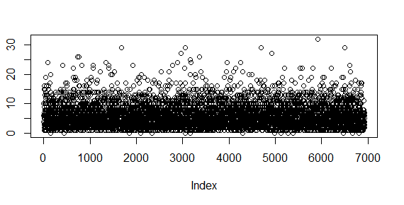

The shape 0.3 resulted in a very low noise and 68% of patients progressing from stage 1 to stage 2 within the first year (49% to stage 3 and 37% to stage 4).

*Figure C2: Noise with the shape equal 0.3 in Weibull distribution*

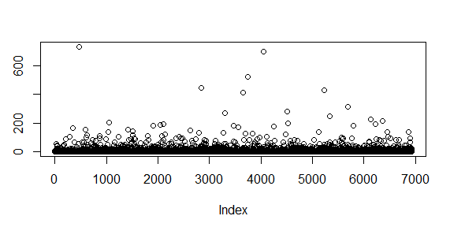

*Table C1: Best fit parameters from three chains*

|  |  |  |  |
| --- | --- | --- | --- |
| Parameter | Chain 1 | Chain 2 | Chain 3 |
| P.onset | 3.95E-05 | 0.000109 | 6.48E-05 |
| P.onset_low.risk | 0.052432608 | 0.024848 | 0.052024305 |
| P.onset_age | 1.230467558 | 1.171792 | 1.181321006 |
| RR.onset_sex | 1.383659466 | 5.254449 | 41.00100100 |
| P.sympt.diag_LGBC | 0.018398778 | 0.008001 | 0.023112938 |
| P.sympt.diag_A_HGBC | 0.000461259 | 0.004033 | 0.005744173 |
| P.sympt.diag_B_HGBC | 1.024939261 | 0.766033 | 0.676443382 |
| P.sympt.diag_Age80_HGBC | 0.717687356 | 0.797279 | 0.989956700 |
| shape.t.StI.StII | 0.70825316 | 1.029116 | 0.601838347 |
| shape.t.StII.StIII | 0.321158779 | 0.822783 | 1.026884181 |
| shape.t.StIII.StIV | 0.517730442 | 1.12614 | 1.080932017 |
| P.LGtoHGBC | 4.91E-05 | 0.001452 | 0.001291111 |

*Table C2: Progression of BC by time*

|  |  |  |  |
| --- | --- | --- | --- |
| Time limit | Onset to stage 2 | Onset to stage 3 | Onset to stage 4 |
| Less than 1 year | 35.1% | 5.4% | 1.1% |
| Less than 3 years | 68.7% | 38.7% | 23.6% |
| More than 10 years | 7.1% | 10.7% | 13% |
| More than 20 years | 1.8% | 2.5% | 2.9% |

The range to report the progression to Stage 2 was reported as 1-7 years. In the model, 89% of patients progressed to stage 2 within this time.

*Table C3: Progression of BC by time: comparison to used data*

|  |  |  |
| --- | --- | --- |
| Progression to stage | The range of the time to stage reported in the qualitative study | The model predictions of the proportion of patients who progress within this indicated range |
| to Stage 2 | 0-7 years | 89.0% |
| to Stage 3 | 0-12 years | 91.0% |
| to Stage 4 | 0-16 years | 94.4% |

*Figure C3: Fit to the different calibration and validation targets at the first calibration attempt*

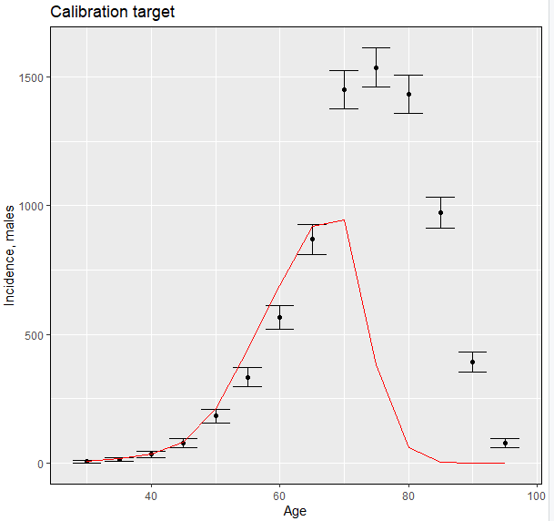

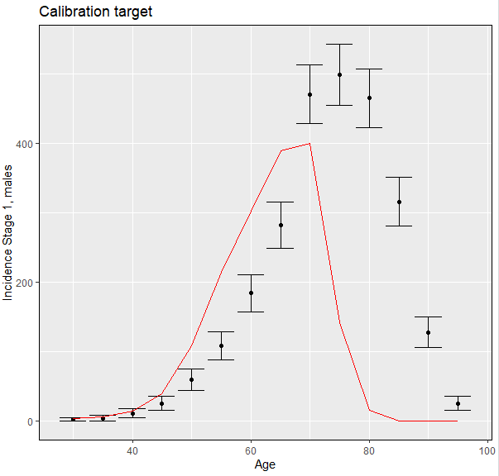

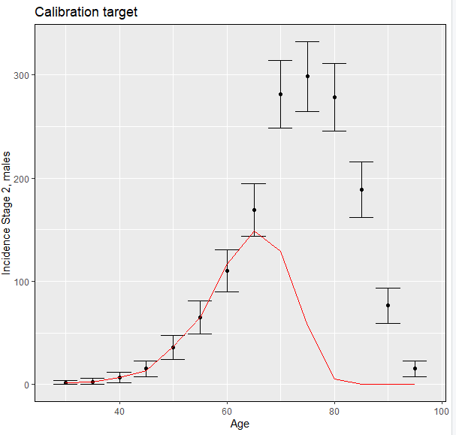

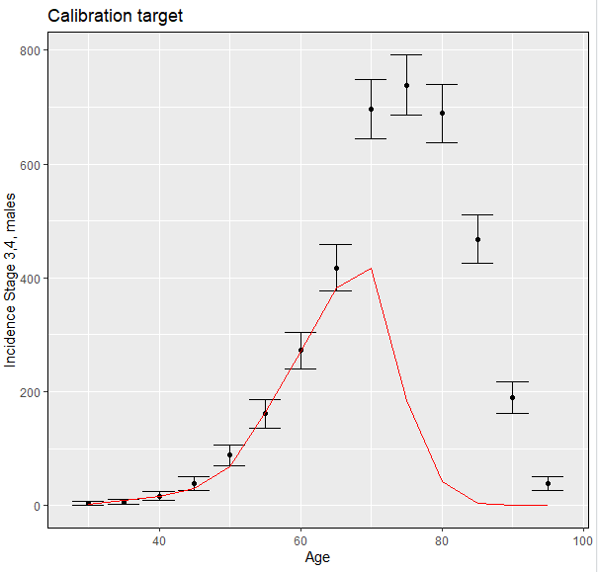

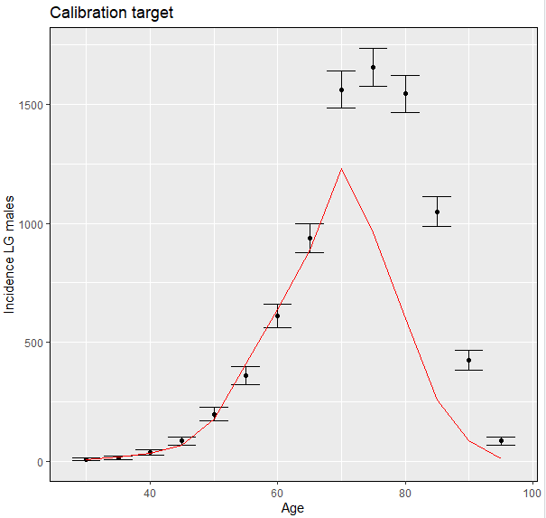

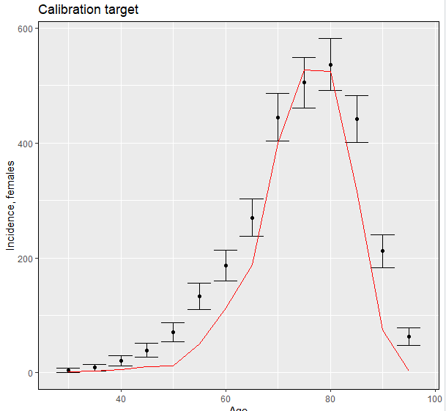

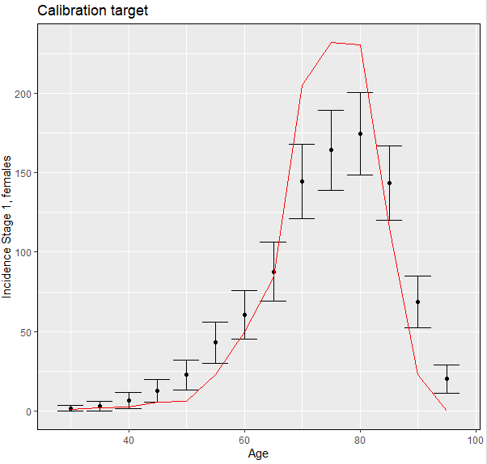

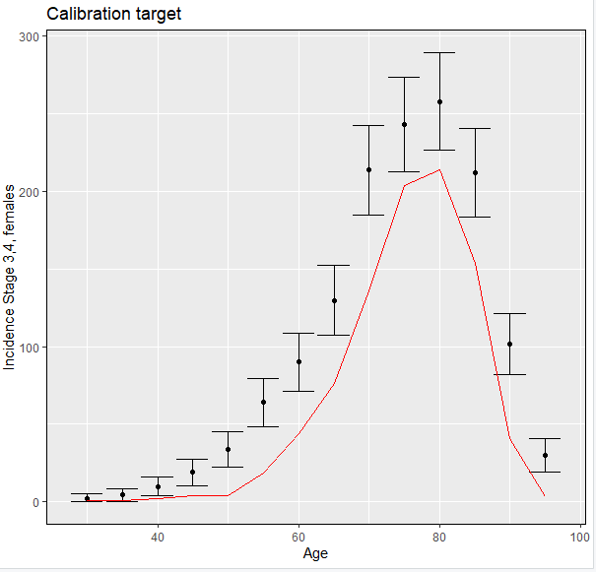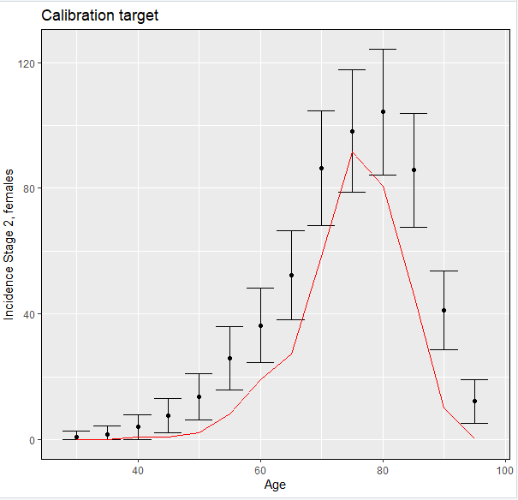

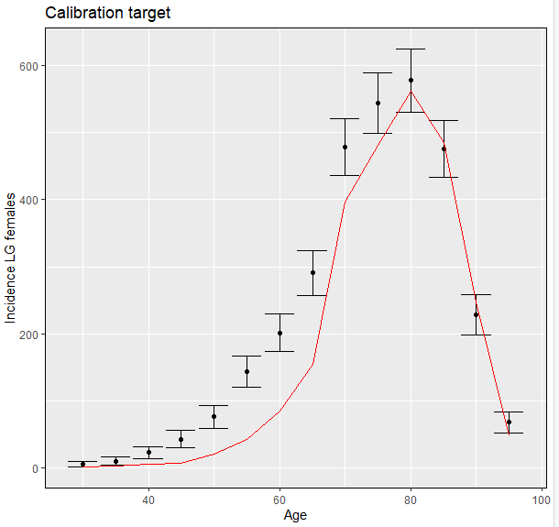

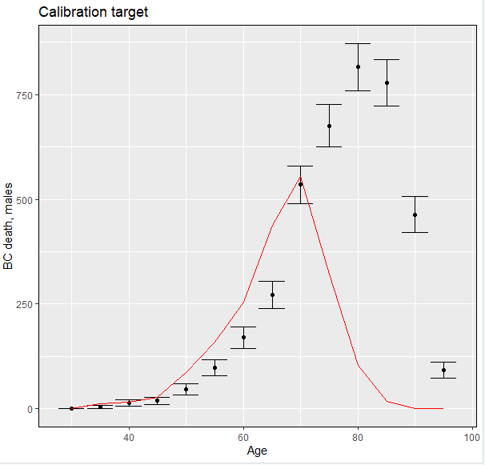

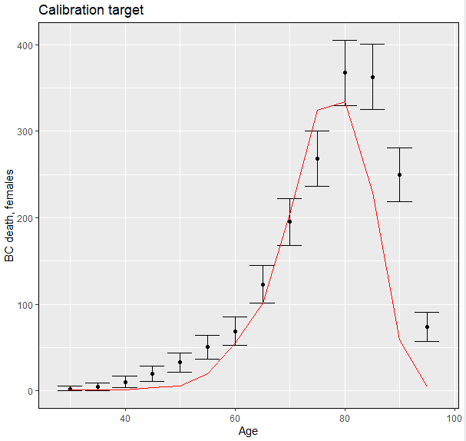

1. Cumberbatch MGK, Jubber I, Black PC, et al. Epidemiology of Bladder Cancer: A Systematic Review and Contemporary Update of Risk Factors in 2018. *Eur Urol* 2018;74(6):784-95. doi: 10.1016/j.eururo.2018.09.001 [published Online First: 2018/10/01]

2. Health Survey for England 2019: NHS Digital, 2019.

3. Dolan P. Modeling valuations for EuroQol health states. *Med Care* 1997;35(11):1095-108.

4. Cumberbatch MG, Rota M, Catto JW, et al. The Role of Tobacco Smoke in Bladder and Kidney Carcinogenesis: A Comparison of Exposures and Meta-analysis of Incidence and Mortality Risks. *Eur Urol* 2016;70(3):458-66. doi: 10.1016/j.eururo.2015.06.042 [published Online First: 2015/07/08]

5. Cumberbatch MG, Windsor-Shellard B, Catto JW. The contemporary landscape of occupational bladder cancer within the United Kingdom: a meta-analysis of risks over the last 80 years. *BJU Int* 2017;119(1):100-09. doi: 10.1111/bju.13561 [published Online First: 2016/06/23]

6. Guidance Arsenic: general information Updated 14 August 2019: Public Health England; 2019 [Available from: <https://www.gov.uk/government/publications/arsenic-properties-incident-management-and-toxicology/arsenic-general-information>.

7. Statistics on NHS Stop Smoking Services in England April 2020 to March 2021 - Data tables. In: digital N, ed. England, 2021.

8. Martin-Lopez JE, Beltran-Calvo C, Rodriguez-Lopez R, et al. Comparison of the accuracy of CT colonography and colonoscopy in the diagnosis of colorectal cancer. *Colorectal Dis* 2014;16(3):O82-9. doi: 10.1111/codi.12506 [published Online First: 2013/12/05]

9. Ara R, Brazier J. Using health state utility values from the general population to approximate baselines in decision analytic models when condition-specific data are not available. *Value in Health* 2011;14(4):539-45.

10. Bladder Cancer (C67): 2016-2018. Average Number of New Cases Per Year and Age-Specific Incidence Rates per 100,000 Population, UK. In: UK CR, ed., 2019.

11. Broder MS, Ailawadhi S, Beltran H, et al. Estimates of stage-specific preclinical sojourn time across 21 cancer types. *Journal of Clinical Oncology* 2021;39(15_suppl):e18584-e84. doi: 10.1200/JCO.2021.39.15_suppl.e18584

12. Linton KD, Rosario DJ, Thomas F, et al. Disease specific mortality in patients with low risk bladder cancer and the impact of cystoscopic surveillance. *J Urol* 2013;189(3):828-33. doi: 10.1016/j.juro.2012.09.084 [published Online First: 2012/09/29]

13. Cox E, Saramago P, Kelly J, et al. Effects of Bladder Cancer on UK Healthcare Costs and Patient Health-Related Quality of Life: Evidence From the BOXIT Trial. *Clinical Genitourinary Cancer* 2020;18(4):e418-e42. doi: <https://doi.org/10.1016/j.clgc.2019.12.004>

14. Dobruch J, Daneshmand S, Fisch M, et al. Gender and Bladder Cancer: A Collaborative Review of Etiology, Biology, and Outcomes. *Eur Urol* 2016;69(2):300-10. doi: 10.1016/j.eururo.2015.08.037 [published Online First: 2015/09/09]

15. Kluth LA, Rieken M, Xylinas E, et al. Gender-specific Differences in Clinicopathologic Outcomes Following Radical Cystectomy: An International Multi-institutional Study of More Than 8000 Patients. *European Urology* 2014;66(5):913-19. doi: <https://doi.org/10.1016/j.eururo.2013.11.040>

16. Soave A, Dahlem R, Hansen J, et al. Gender-specific outcomes of bladder cancer patients: A stage-specific analysis in a contemporary, homogenous radical cystectomy cohort. *European Journal of Surgical Oncology (EJSO)* 2015;41(3):368-77. doi: <https://doi.org/10.1016/j.ejso.2014.03.003>

17. Otto W, May M, Fritsche H-M, et al. Analysis of Sex Differences in Cancer-Specific Survival and Perioperative Mortality Following Radical Cystectomy: Results of a Large German Multicenter Study of Nearly 2500 Patients with Urothelial Carcinoma of the Bladder. *Gender Medicine* 2012;9(6):481-89. doi: <https://doi.org/10.1016/j.genm.2012.11.001>

18. Average Number of Deaths Per Year and Age-Specific Mortality Rates per 100,000 Population, UK: Cancer Research UK, 2022.

19. Vanni T, Karnon J, Madan J, et al. Calibrating models in economic evaluation: a seven-step approach. *Pharmacoeconomics* 2011;29(1):35-49. doi: 10.2165/11584600-000000000-00000 [published Online First: 2010/12/15]

20. Menzies NA, Soeteman DI, Pandya A, et al. Bayesian Methods for Calibrating Health Policy Models: A Tutorial. *Pharmacoeconomics* 2017;35(6):613-24. doi: 10.1007/s40273-017-0494-4 [published Online First: 2017/03/02]

21. Adult Cancer Survival Tables: One and Five Year net survival for adults diagnosed between 2013 and 2017, England: Office for National Statistics; [Available from: <https://www.ons.gov.uk/peoplepopulationandcommunity/healthandsocialcare/conditionsanddiseases/datasets/cancersurvivalratescancersurvivalinenglandadultsdiagnosed> accessed 20th October 2019.

22. Survival for bladder cancer: Cancer Research UK, 2022.

23. Pirie K, Peto R, Reeves GK, et al. The 21st century hazards of smoking and benefits of stopping: a prospective study of one million women in the UK. *The Lancet* 2013;381(9861):133-41. doi: <https://doi.org/10.1016/S0140-6736(12)61720-6>

24. Lyratzopoulos G, Abel GA, McPhail S, et al. Gender inequalities in the promptness of diagnosis of bladder and renal cancer after symptomatic presentation: evidence from secondary analysis of an English primary care audit survey. *BMJ Open* 2013;3(6) doi: 10.1136/bmjopen-2013-002861 [published Online First: 2013/06/27]

25. Moss S, Mathews C, Day TJ, et al. Increased uptake and improved outcomes of bowel cancer screening with a faecal immunochemical test: results from a pilot study within the national screening programme in England. *Gut* 2017;66(9):1631-44. doi: 10.1136/gutjnl-2015-310691 [published Online First: 2016/06/09]